A
Learning Project Report
On

“An Interview Trainer”

Submitted in partial fulfillment of
The requirements for the 4th Semester Sessional Examination of

BACHELOR OF TECHNOLOGY
IN
COMPUTER SCIENCE & ENGINEERING-AIML

By
Nitin prasad Singh
Swadhin kumar Panda
Subhashree Panda
Registration No.
24UG010701
24UG010689
24UG010693

DEPARTMENT OF COMPUTER SCIENCE & ENGINEERING-
ARTIFICIAL INTELLIGENCE AND MACHINE LEARNING

GANDHI INSTITUTE OF ENGINEERING AND TECHNOLOGY
UNIVERSITY, ODISHA, GUNUPUR
APRIL 2026

GANDHI INSTITUTE OF ENGINEERING AND TECHNOLOGY
UNIVERSITY, ODISHA, GUNUPUR
Dist. - Rayagada-765022, Visit us:-www.giet.edu

Department of Computer Science & Engineering- ARTIFICIAL INTELLIGENCE AND MACHINE LEARNING

CERTIFICATE

This is to certify that the project work entitled “An Interview trainer” is done by Name- Nitin prasad Singh, Swadhin Kumar Panda, Subhashree Panda
Regd. No.- 24UG010701, 24UG010689, 24UG010693 in partial fulfillment of the requirements for the 4th Semester Sessional Examination of Bachelor of Technology in Computer Science and Engineering-AIML during the academic year 2025-26. This work is submitted to the department as a part of evaluation of 4th Semester Learning Project.

Proctor/Class Teacher Project Coordinator, 2nd Year

Asst HoD, 2024-2028 Batch

ACKNOWLEDGEMENT
We would like to express our heartfelt gratitude to our esteemed Proctor/Class Teacher, Mr. Sankar Patra, Department of Computer Science and Engineering, for providing us with the opportunity to undertake this project. His active support and guidance have been instrumental in the successful completion of this project report.

We also extend our sincere thanks to Mr. Bhavani Sankar Panda, Project Coordinator, Computer Science and Engineering-AIML, Dr. AVS Pavan Kumar, Asst. HoD, 2024-2028 Batch, Computer Science and Engineering-AIML, and Prof. (Dr.) Kakita Murali Gopal, Deputy Dean, Computational Science, SOET, for their consistent support, guidance, and assistance.

Furthermore, we would like to thank our friends and family members for their unwavering support and encouragement throughout the project's execution. Their contributions have been invaluable to us.

Nitin prasad Singh (24UG010701)
Swadhin Kumar Panda (24UG010689)
Subhashree Panda (24UG010693)

ABSTRACT

HirableAI is a full-stack web application developed to enhance interview preparation by leveraging Artificial Intelligence and Natural Language Processing techniques. The system enables users to upload their resume in PDF format and automatically generates personalized interview questions based on the extracted content. Unlike traditional mock interview platforms that rely on generic question banks, HirableAI uses a retrieval-augmented approach to tailor questions according to the candidate’s skills, experience, and projects.

The backend of the application is built using FastAPI and integrates a locally hosted Large Language Model (LLM) through Ollama, ensuring low latency and offline capability. Resume content is processed using PyMuPDF for text extraction, followed by segmentation into meaningful chunks. These chunks are converted into vector embeddings using the sentence-transformers model, enabling semantic similarity search. This allows the system to retrieve the most relevant portions of the resume when generating questions and evaluating responses.

The application also evaluates user answers across multiple dimensions, including confidence, communication clarity, and technical knowledge. It provides structured feedback and scoring, helping users identify strengths and areas for improvement. The frontend is implemented using HTML, CSS, and JavaScript, offering an intuitive multi-page interface for seamless interaction.

Overall, HirableAI demonstrates an effective integration of AI-driven evaluation, semantic search, and full-stack web technologies. It serves as a scalable prototype for intelligent interview preparation systems, with potential for further enhancement through persistent storage, secure authentication, and advanced analytics.

INDEX PAGE

Sl.no. | Section Title | Page No.
1 | Introduction | 1-4
1.1 | Purpose | 2
1.2 | Scope | 2-3
1.3 | Features | 3-4
2 | Literature Review | 5
3 | System Analysis | 6-8
3.1 | User Requirements | 6
3.2 | Hardware Requirements | 7
3.3 | Software Requirements | 7-8
4 | System Design & Specifications | 9-13
4.1 | High-Level Design (HLD) | 9
4.1.1 | Project Model | 9
4.1.2 | Flow Chart | 10
4.1.3 | E-R Diagram | 11
4.2 | Low-Level Design (LLD) | 12-13
4.2.1 | Process Specification | 12-13
5 | Methodology | 14-16
6 | Implementation | 17-37
7 | Conclusion & Future Scope | 38-39
8 | References / Bibliography | 40

INTRODUCTION
HirableAI is an advanced AI-powered web application developed to enhance the process of interview preparation by providing a personalized and interactive experience to users. In the current competitive job landscape, candidates are expected not only to possess strong technical knowledge but also to demonstrate effective communication and confidence during interviews. However, many existing preparation methods rely on generic question banks, online tutorials, or peer discussions, which often fail to adapt to an individual’s unique profile. This creates a gap between preparation and actual interview performance.
The HirableAI system is designed to bridge this gap by leveraging Artificial Intelligence and Natural Language Processing (NLP) techniques to create a customized interview environment. The application allows users to upload their resumes in PDF format, which are then analysed to extract meaningful information such as skills, experience, education, and projects. Based on this extracted data, the system generates relevant and context-aware interview questions tailored specifically to the candidate’s background. This ensures that users are exposed to questions that closely resemble those asked in real-world interviews.
In addition to question generation, HirableAI evaluates user responses using an AI model integrated through a local Large Language Model (LLM) framework. The system assesses answers on multiple parameters, including confidence, communication clarity, and technical understanding. It then provides structured feedback and scores, enabling users to identify their strengths and areas that require improvement. This dual functionality of personalized questioning and intelligent evaluation makes the system highly effective for self-assessment and skill enhancement.
The application is built using a full-stack architecture, with the frontend developed using HTML, CSS, and JavaScript, and the backend implemented using FastAPI in Python. The AI capabilities are powered by a locally hosted model via Ollama, which ensures privacy, reduced latency, and independence from external APIs. Additionally, the system employs embedding techniques using sentence-transformers
to perform semantic similarity searches, enabling accurate retrieval of relevant resume content during both question generation and answer evaluation.

1.1 PURPOSE
The primary purpose of HirableAI is to create an intelligent, user-friendly platform that assists individuals in preparing for interviews in a structured and personalized manner. The system is designed to simulate a realistic interview scenario where users can practice answering questions derived directly from their own resumes.
The key objectives include:
- Providing personalized interview questions based on individual resume content
- Enabling users to practice interviews in a self-paced environment
- Offering AI-driven evaluation of answers to improve performance
- Helping users build confidence and communication skills
- Reducing dependency on external coaching or mock interview services
By fulfilling these objectives, HirableAI aims to make interview preparation more efficient, accessible, and data-driven.
1.2 SCOPE
The scope of this project is centred on developing a working prototype that demonstrates the integration of Artificial Intelligence with modern web technologies. The application is primarily intended for local deployment and testing, making it suitable for academic and experimental purposes.
The system focuses on the following functional areas:
- Uploading and processing resumes in PDF format
- Extracting and structuring textual data from resumes
- Performing semantic analysis using embedding models
- Generating interview questions using AI models
- Evaluating user responses with structured scoring metrics
- Displaying results through an interactive user interface
While the system successfully demonstrates these capabilities, it operates within certain limitations. It does not include advanced production-level features such as secure authentication systems, cloud-based deployment, persistent databases, or large-scale user management. Data is stored temporarily in memory and browser local Storage, which means it is not retained after a session ends or the server restarts.
Despite these limitations, the scope of HirableAI effectively showcases the potential of AI-driven interview preparation systems and lays the foundation for future enhancements.

1.3 FEATURES
Hirable AI incorporates a range of features that collectively provide a comprehensive interview preparation experience.
Resume Upload Functionality:
Users can upload their resumes in PDF format. The system validates the file type and processes it securely.
Automated Text Extraction:
The application uses PDF parsing techniques to extract text from the uploaded resume and organize it into meaningful sections.
Content Segmentation and Chunking:
The extracted text is divided into smaller chunks to facilitate efficient processing and semantic analysis.
Semantic Search with Embeddings:
Each chunk is converted into a numerical vector representation using an embedding model, enabling accurate similarity-based retrieval.
Personalized Question Generation:
The system generates interview questions tailored to the candidate’s resume using an AI model, ensuring relevance and realism.
Interactive Interview Interface:
Users are presented with one question at a time, along with progress tracking and a timer to simulate real interview conditions.
AI-Based Answer Evaluation:
Responses are evaluated based on multiple parameters such as confidence, communication, and technical knowledge.
Detailed Feedback System:
The application provides constructive feedback to help users improve their answers and overall performance.
Results Visualization:
Final scores are displayed using graphical elements such as progress bars and summaries for better understanding.
Lightweight and Efficient Architecture:
The system operates without a traditional database, using in-memory storage and browser local storage for fast performance.
Fallback Mechanisms:
In case of AI model failure, the system provides default questions and evaluation scores to ensure uninterrupted functionality.

LITERATURE REVIEW
The development of HirableAI is influenced by advancements in Artificial Intelligence, Natural Language Processing (NLP), and intelligent web-based systems. Traditional interview preparation platforms primarily rely on static question banks and generic mock interviews, which do not adapt to individual user profiles. Studies in personalized learning systems suggest that tailored content significantly improves user engagement and learning outcomes, highlighting the need for systems that adapt to user-specific data such as resumes.
Natural Language Processing techniques have been widely used in applications like resume parsing, chatbots, and automated evaluation systems. Tools for PDF text extraction and preprocessing enable the conversion of unstructured resume data into structured formats that can be analysed effectively. Furthermore, embedding models such as sentence-transformers have improved semantic understanding by representing text as numerical vectors, allowing systems to measure contextual similarity rather than relying solely on keyword matching.
Another key concept is Retrieval-Augmented Generation (RAG), which combines information retrieval with language generation to produce context-aware outputs. This approach enhances the relevance and accuracy of AI-generated responses. Additionally, Large Language Models (LLMs) have shown strong capabilities in generating human-like text and evaluating responses, making them suitable for interview simulation systems.
Overall, existing research supports the integration of semantic search, AI-based generation, and evaluation techniques, which form the foundation of HirableAI.

SYSTEM ANALYSIS
System analysis is an important phase in the development of HirableAI, as it identifies what the system is expected to do and the resources required for its proper functioning. This phase ensures that user needs are clearly understood and translated into system specifications. It also defines the technical and operational environment in which the application is developed and executed.
3.1 USER REQUIREMENT
User requirements define what the end users expect from the system in terms of functionality, usability, and performance. HirableAI is primarily targeted at students, job seekers, and professionals preparing for interviews.
Functional Requirements:
- The system should allow users to upload resumes in PDF format.
- The system should extract and read the content of the resume.
- The system should generate interview questions based on the resume.
- The system should allow users to enter answers for each question.
- The system should evaluate answers using AI.
- The system should provide scores for:
  - Confidence
  - Communication
  - Technical knowledge
- The system should give feedback to help users improve.
- The system should display final results in a clear format.
- The system should allow smooth navigation between pages.
Non-Functional Requirements:
- The system should be easy to use (user-friendly).
- The system should respond quickly.
- The system should work without errors or crashes.
- The system should be simple to maintain and update.
- The system should handle basic security like file validation.

3.2 HARDWARE REQUIREMENTS
The hardware requirements for HirableAI are minimal, as it is designed for local execution and lightweight processing.
- A computer or laptop is required.
- Processor: Minimum dual-core CPU.
- RAM: At least 8 GB (recommended for smooth performance).
- Storage: Minimum 2 GB free space.
- Input devices: Keyboard and mouse.
- Output device: Monitor or display screen.
- Optional: Higher RAM or GPU for better AI performance.
3.3 SOFTWARE REQUIREMENTS
The software requirements define the tools, frameworks, and environments needed to develop and run the system.
Operating System
- Windows, Linux, or macOS
Programming and Frameworks
- Python (backend development)
- FastAPI (API framework)
- Uvicorn (server)
Frontend Technologies
- HTML
- CSS
- JavaScript
Libraries and Tools
- PyMuPDF (for PDF reading)
- sentence-transformers (for text understanding)
- NumPy (for calculations)
- python-multipart (for file upload)
- Requests (for API calls)
AI Tools
- Ollama (for running AI model locally)
- Embedding model (all-MiniLM-L6-v2)
Browser
- Google Chrome or Microsoft Edge

SYSTEM DESIGN & SPECIFICATION
4.1 High Level Design (HLD)
4.1.1 Project Model
HirableAI follows a Client-Server Model.
- Client (Frontend):
  - Built using HTML, CSS, JavaScript
  - Handles user interaction
  - Sends requests to backend APIs
- Server (Backend):
  - Built using FastAPI
  - Processes user requests
  - Handles AI logic, resume parsing, and evaluation
- AI Layer:
  - Uses embedding model for semantic search
  - Uses LLM (via Ollama) for question generation and evaluation
- Storage:
  - In-memory storage for embeddings
  - local Storage in browser for session data

    - Flowchart
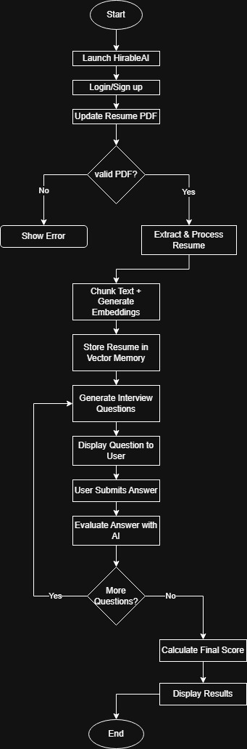
4.1.3 Entity-Relationship Diagram (E-R Diagram)
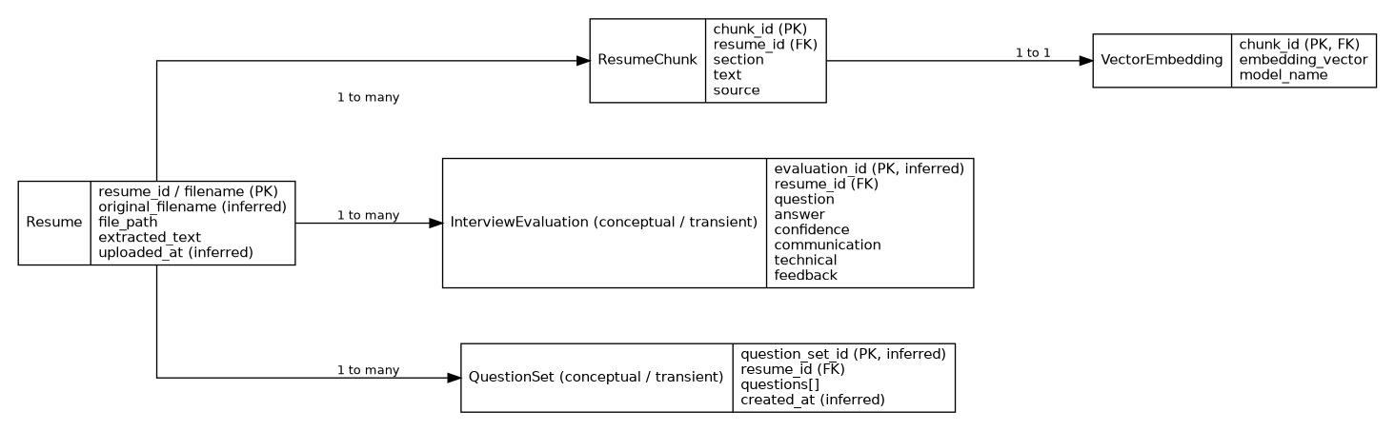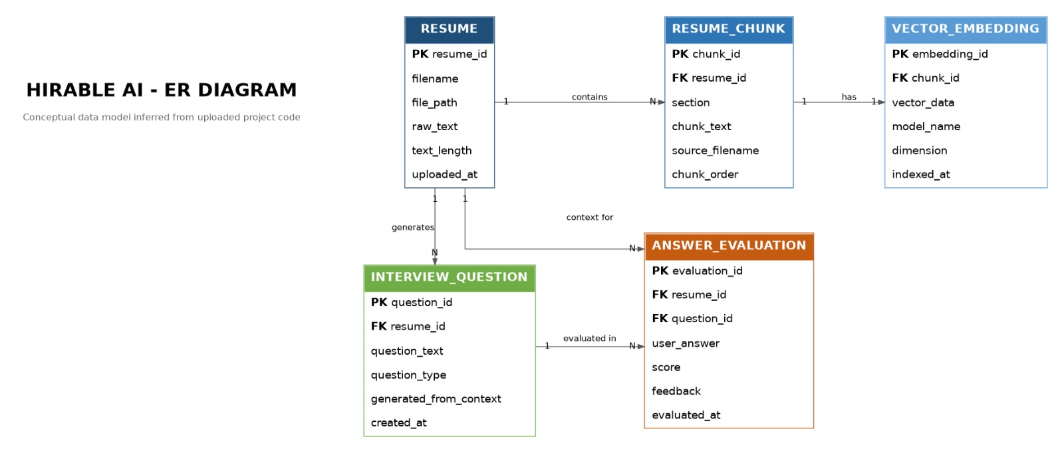
4.2 LOW-LEVEL DESIGN (LLD)
Low-Level Design (LLD) describes the internal working of the system in detail. It explains how each process is executed step by step, including logic, algorithms, and user interface structure.
    - Process Specification
The process specification explains how the system performs each operation:
Step 1: Resume Upload
- The user selects a PDF file from their device.
- The system checks if the file is in PDF format.
- The file is saved on the server with a unique name.
Step 2: Text Extraction
- The system uses PyMuPDF to open the PDF.
- Text is extracted from all pages.
- The extracted text is stored for processing.
Step 3: Text Cleaning and Chunking
- Extra spaces and unwanted characters are removed.
- The text is divided into smaller parts called chunks.
- Overlapping chunks are created to maintain context.
Step 4: Embedding Generation
- Each chunk is converted into a vector using an embedding model.
- These vectors help in understanding the meaning of the text.
Step 5: Question Generation
- The system finds the most relevant chunks.
- These chunks are sent to the AI model.
- The AI generates interview questions based on the content.
Step 6: Answer Evaluation
- The user submits an answer.
- The system combines the question and answer.
- Relevant chunks are retrieved again.
- The AI evaluates the answer and gives scores.
Step 7: Result Display
- Scores are calculated and averaged.
- Feedback is generated.
- Results are displayed to the user.

METHODOLOGY
The methodology of HirableAI defines the step-by-step approach followed to design, develop, and implement the system. It focuses on how different technologies and processes are combined to achieve the goal of AI-powered interview preparation. The project follows a structured and modular development approach to ensure clarity, flexibility, and ease of implementation.
Development Approach:
HirableAI follows an incremental and modular development approach, where the system is divided into smaller components such as resume processing, question generation, answer evaluation, and frontend interaction. Each module is developed and tested independently before integration. This approach helps in identifying errors early and simplifies debugging.
Data Processing Method:
The system begins by collecting input data in the form of a user-uploaded resume. The methodology for processing this data includes:
Text Extraction:
The resume is processed using a PDF parsing library to extract raw text.
Text Cleaning:
The extracted text is cleaned by removing unnecessary spaces and formatting issues.
Text Chunking:
The cleaned text is divided into smaller overlapping chunks. This ensures that context is preserved and improves the accuracy of further processing.
Semantic Analysis Method:
HirableAI uses embedding-based semantic analysis:
- Each text chunk is converted into a numerical vector using a pre-trained embedding model.
- These vectors represent the meaning of the text.

- When a query is made, similarity is calculated between vectors to find the most relevant content.
This method is more effective than keyword matching because it understands context and meaning.
Retrieval-Augmented Generation (RAG):
The system follows a Retrieval-Augmented Generation approach, which involves:
- Retrieving relevant resume chunks based on a query
- Passing the retrieved data as context to the AI model
- Generating responses (questions or evaluations) using this context
This ensures that outputs are personalized and accurate.
AI-Based Evaluation Method:
The system uses a local AI model to evaluate answers:
- The user’s answer is combined with the question
- Relevant resume data is retrieved
- The AI model analyses the response
- Scores are generated for:
  - Confidence
  - Communication
  - Technical knowledge
The system also generates feedback to guide improvement.
Frontend Interaction Method:
The frontend follows a step-by-step interaction flow:
- Upload resume
- Generate questions
- Answer questions one by one
- View final results
Data is temporarily stored using browser local Storage to maintain session flow.
Error Handling and Fallback Method:
To ensure reliability:
- If the AI model fails, the system provides default questions
- If evaluation fails, fallback scores and feedback are returned
- Basic validation is applied for file uploads
Testing Method:
Each module is tested individually (unit testing), followed by integration testing to ensure all components work together correctly.

IMPLEMENTATION
6.1 Frontend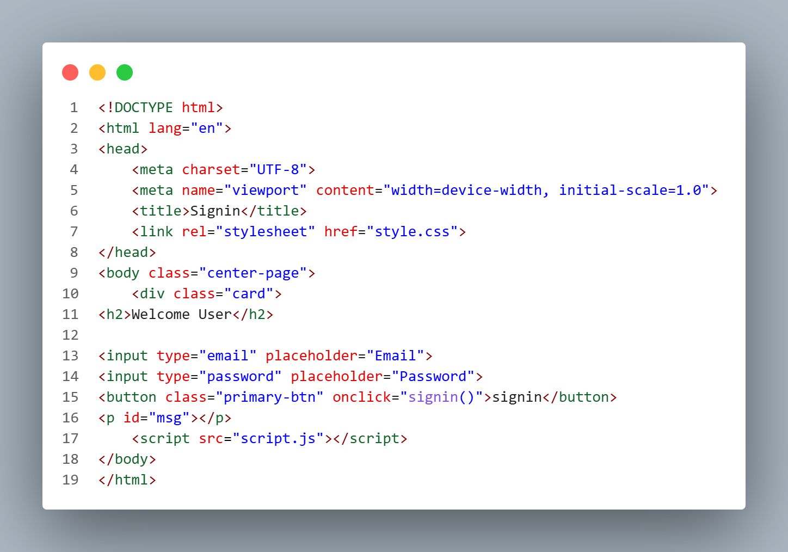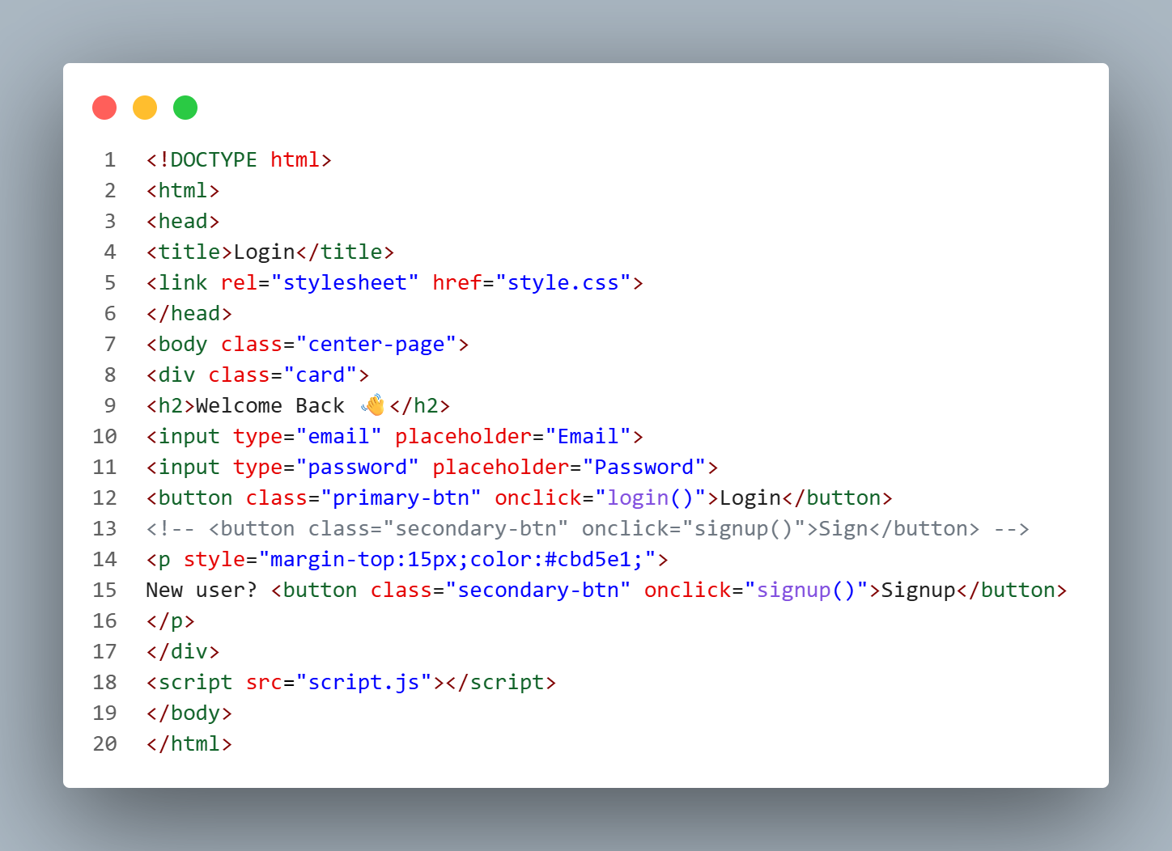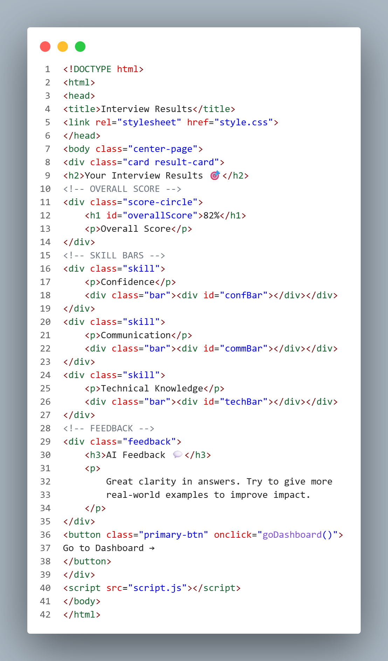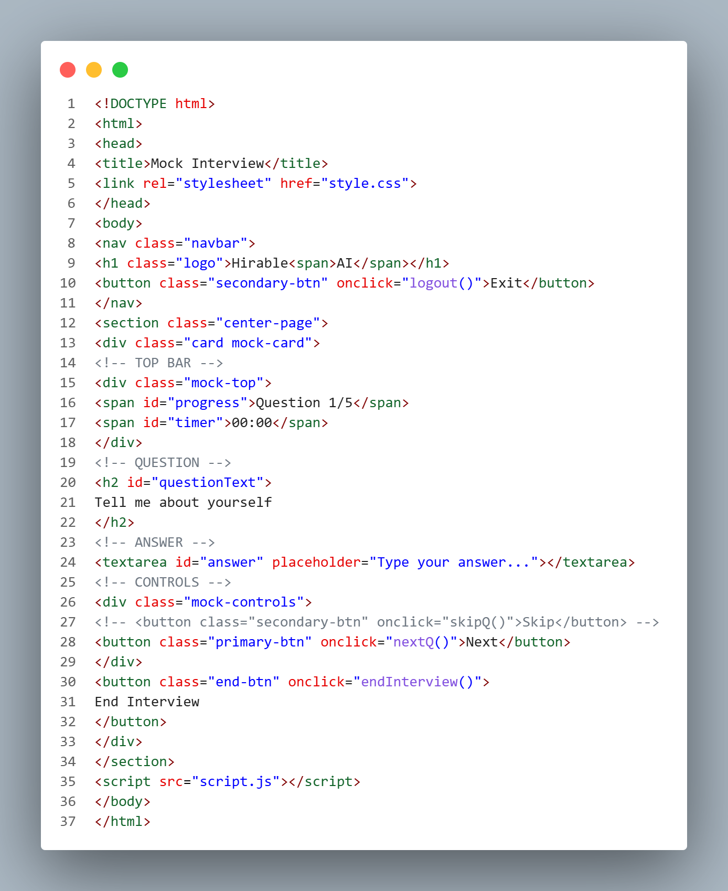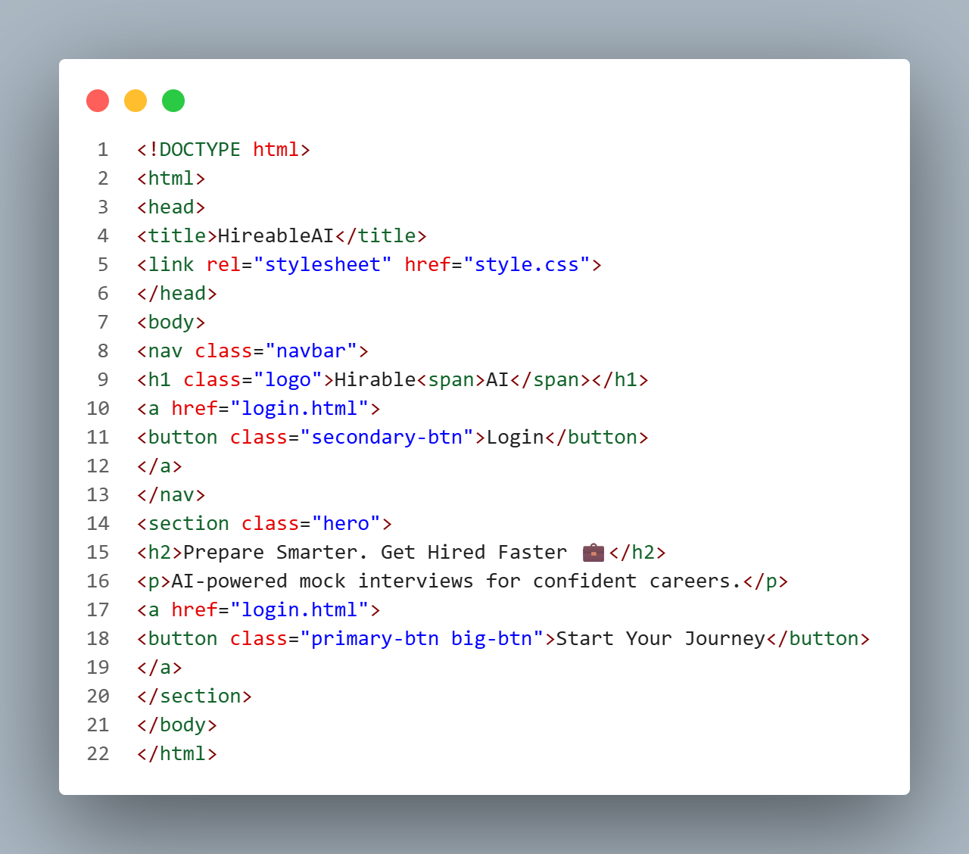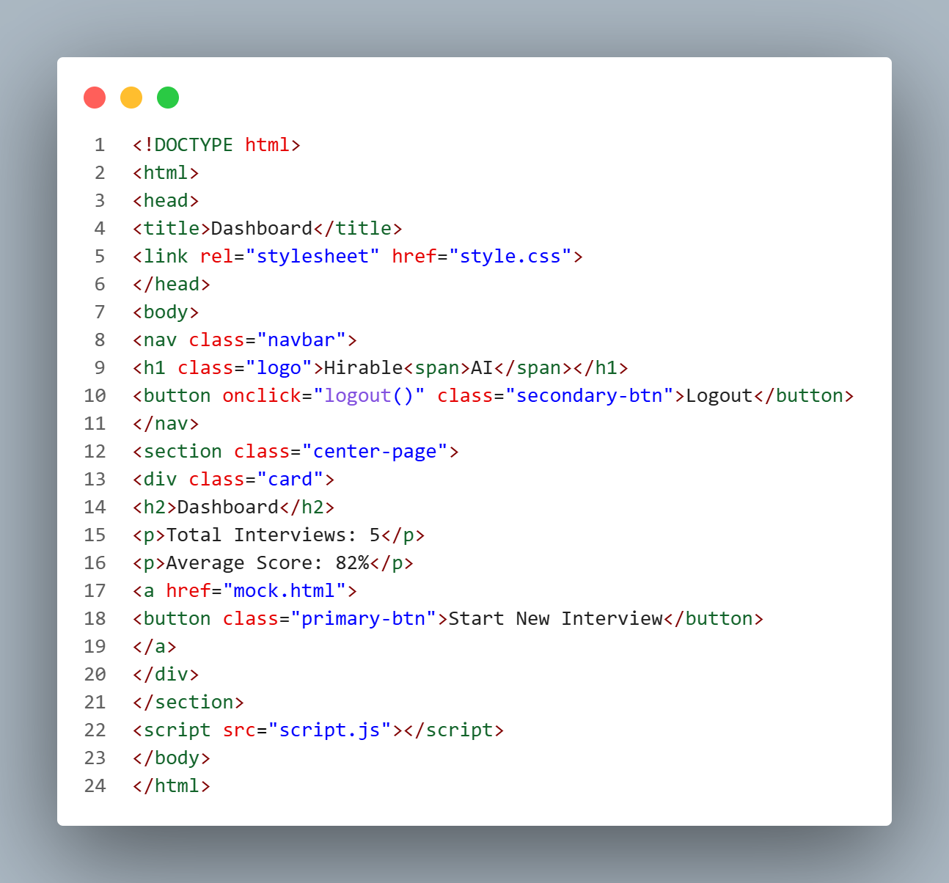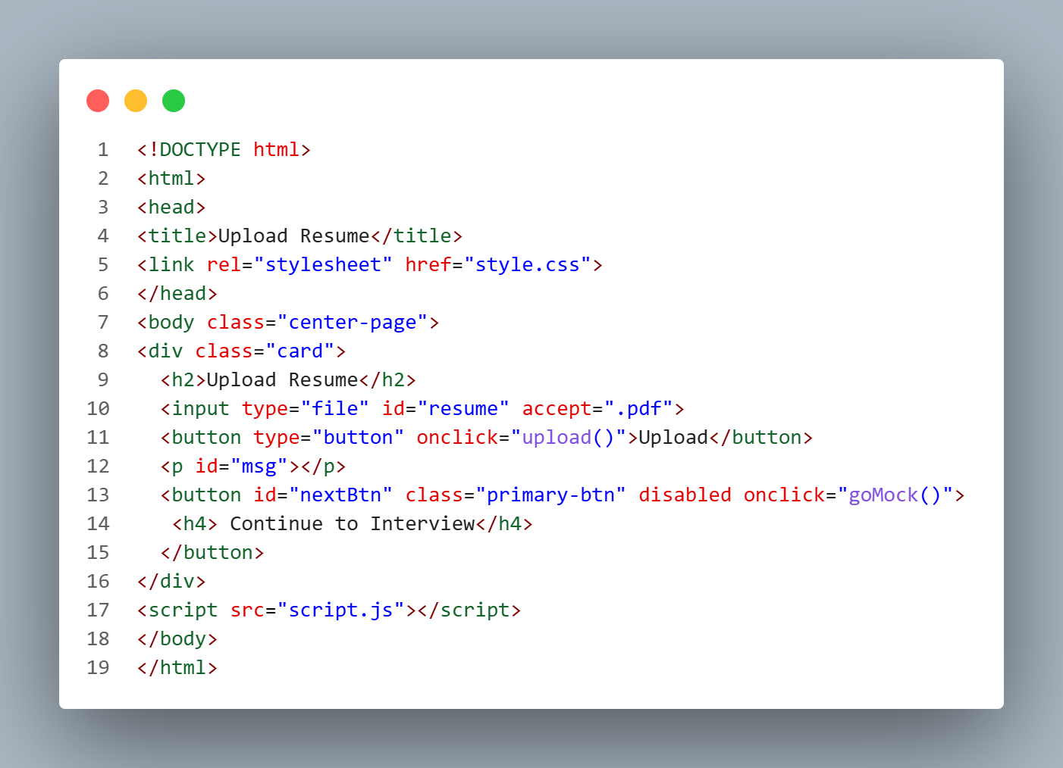

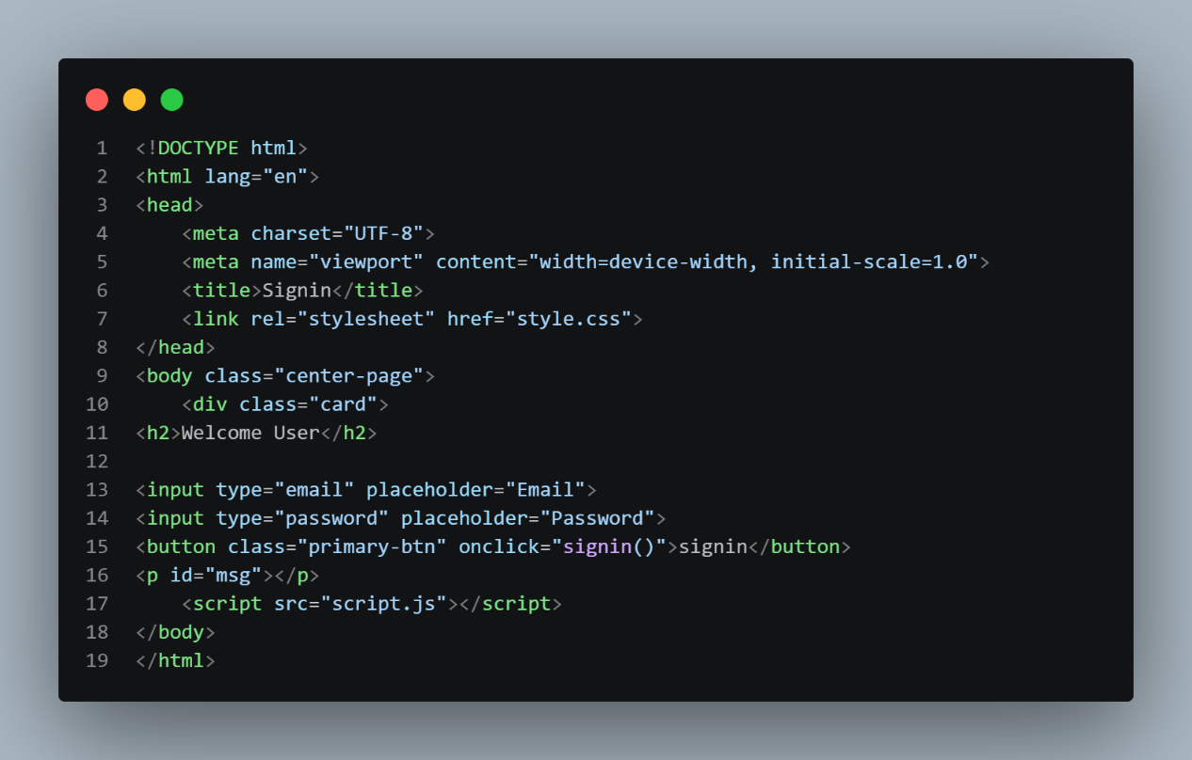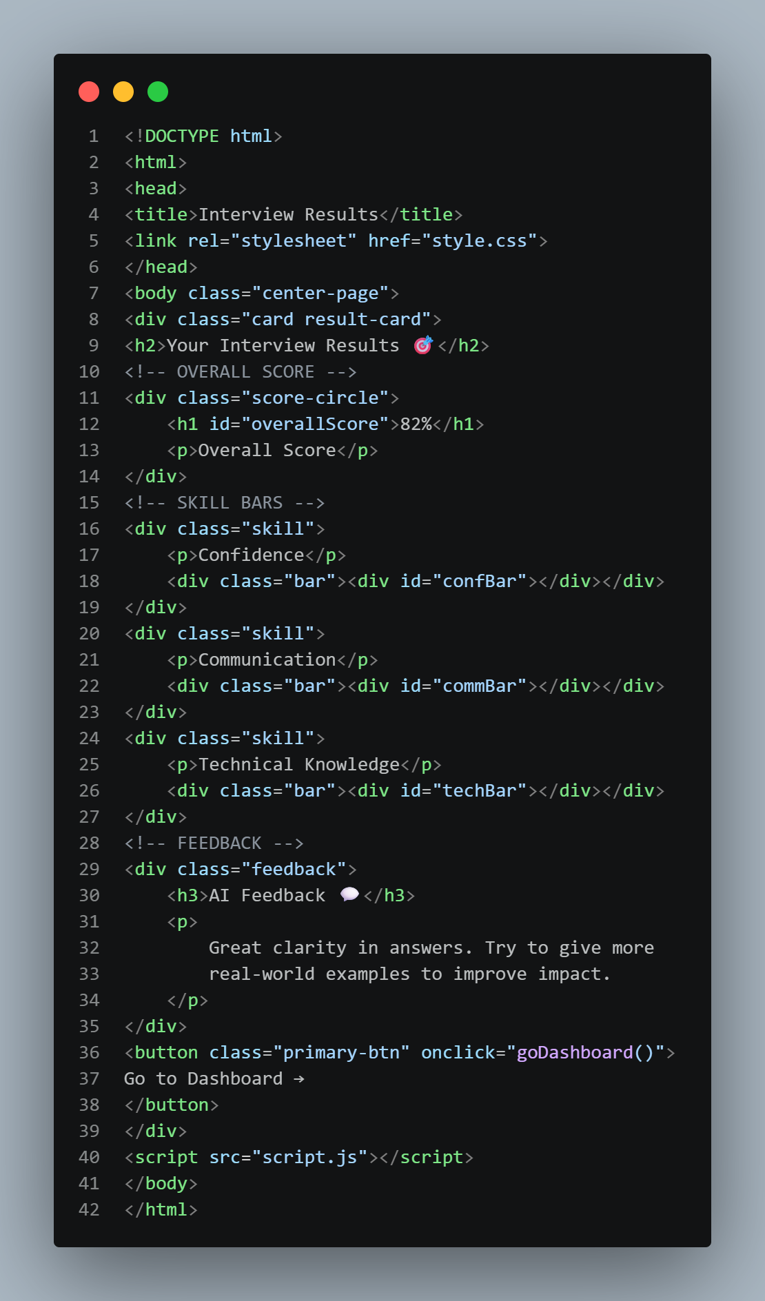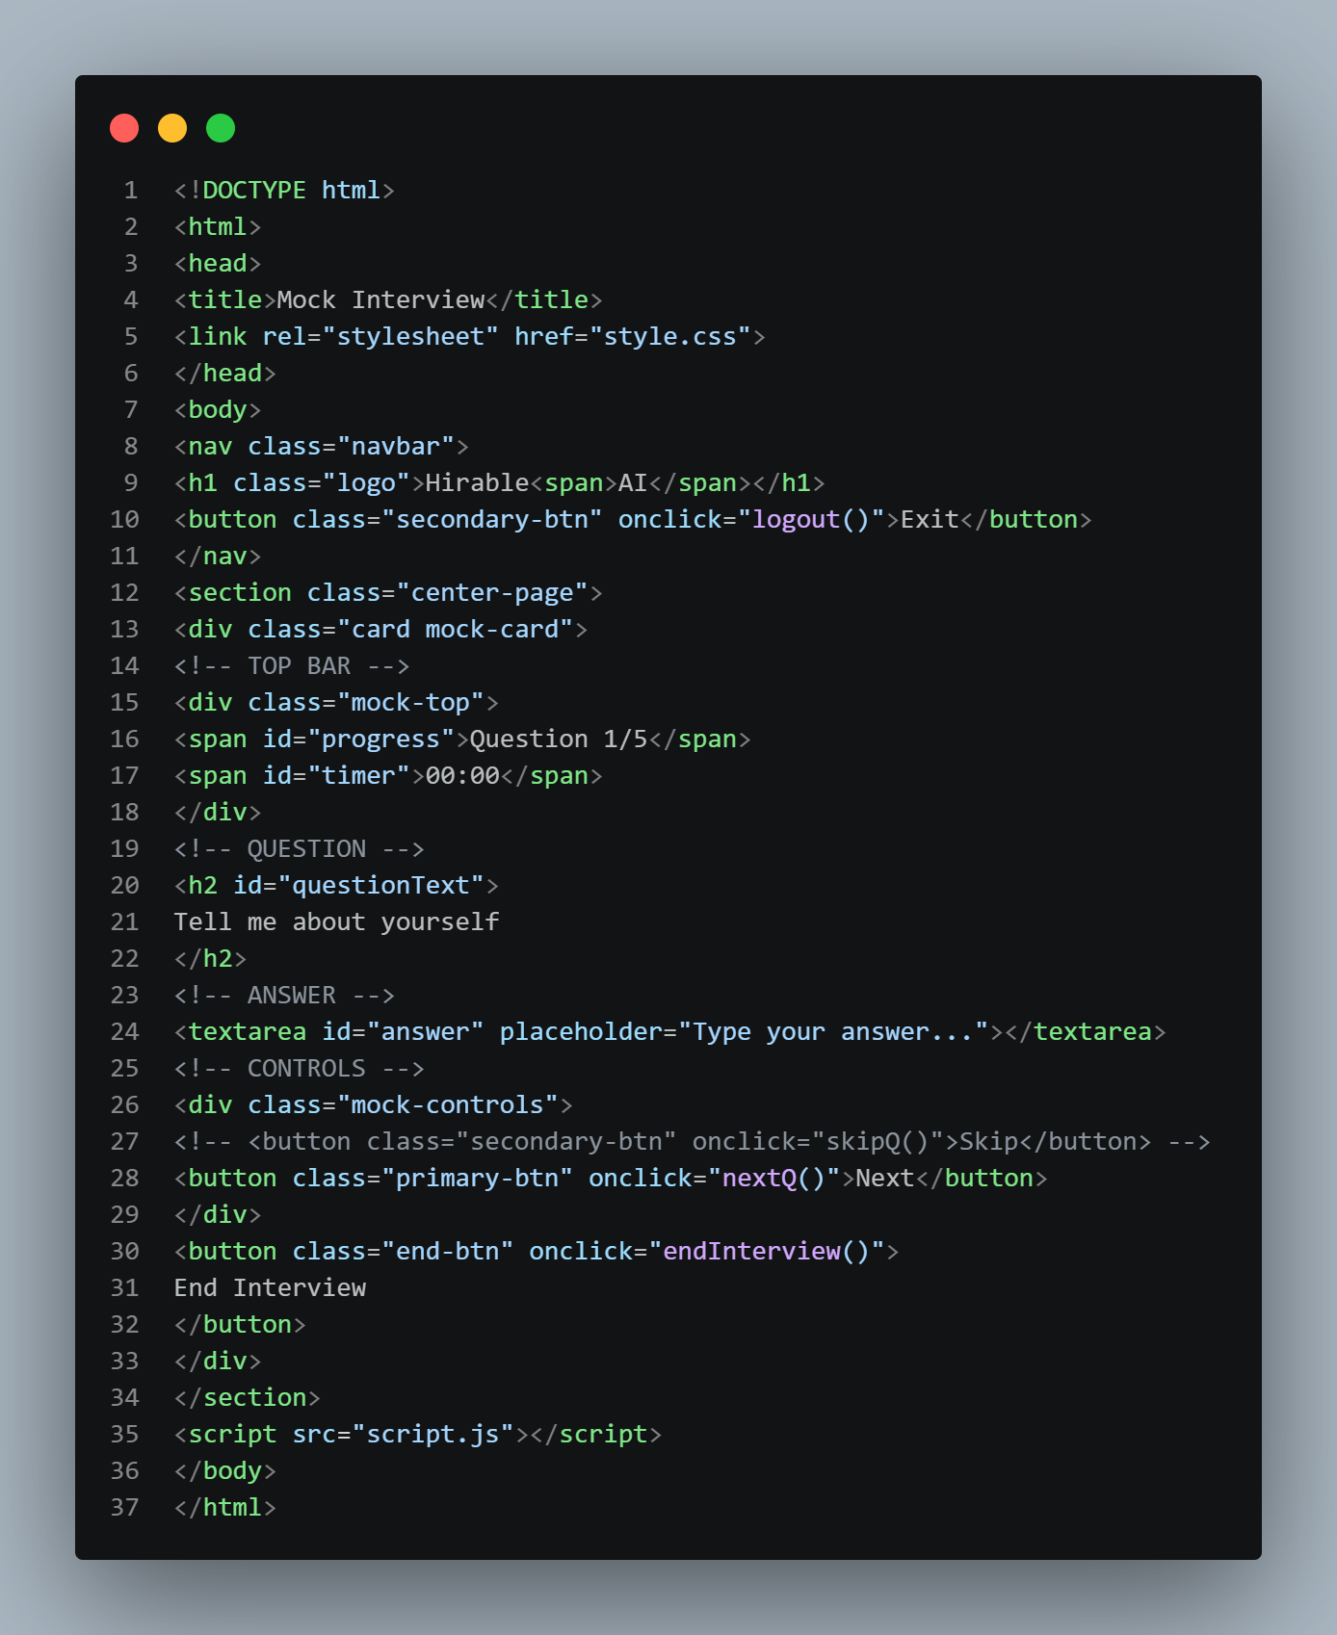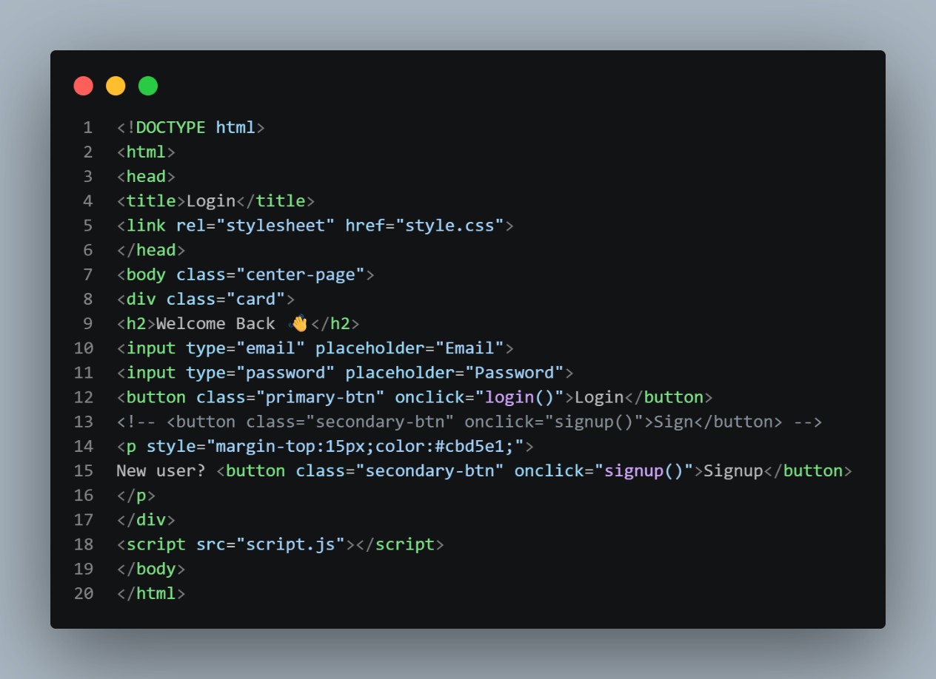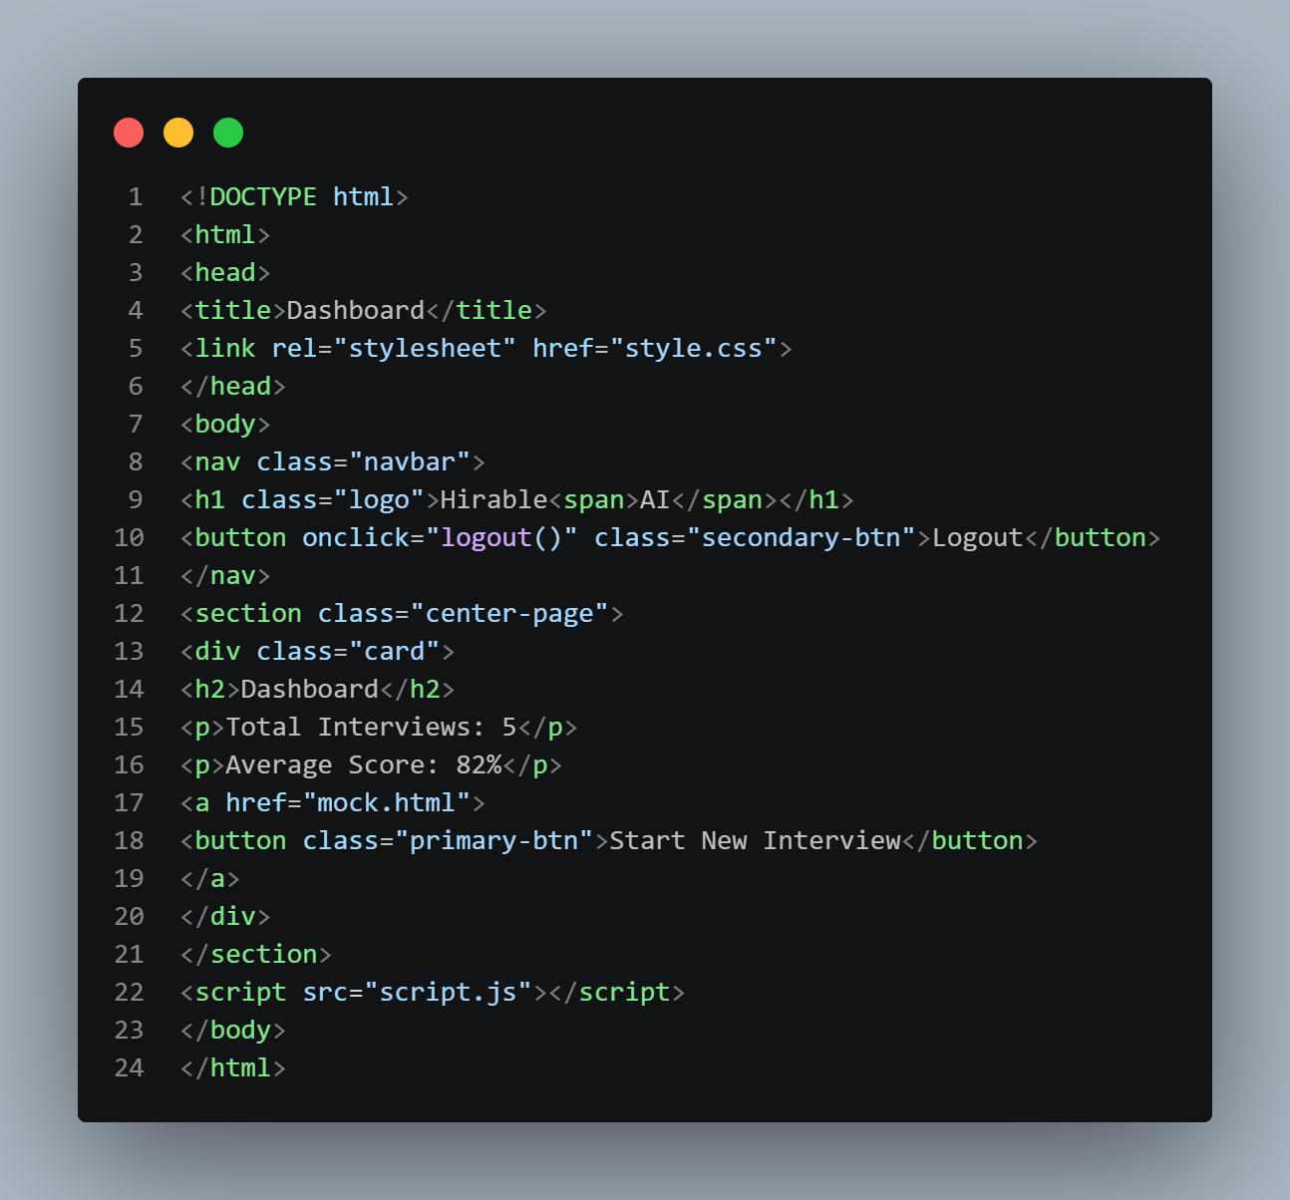
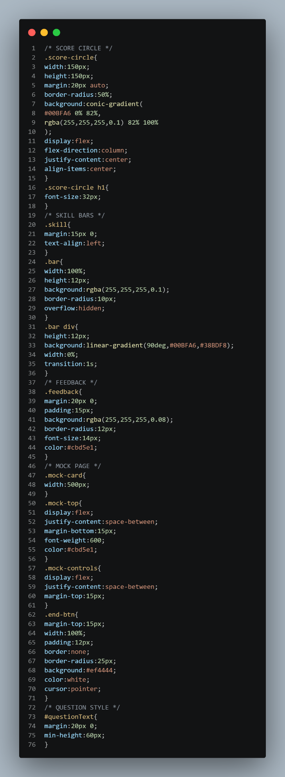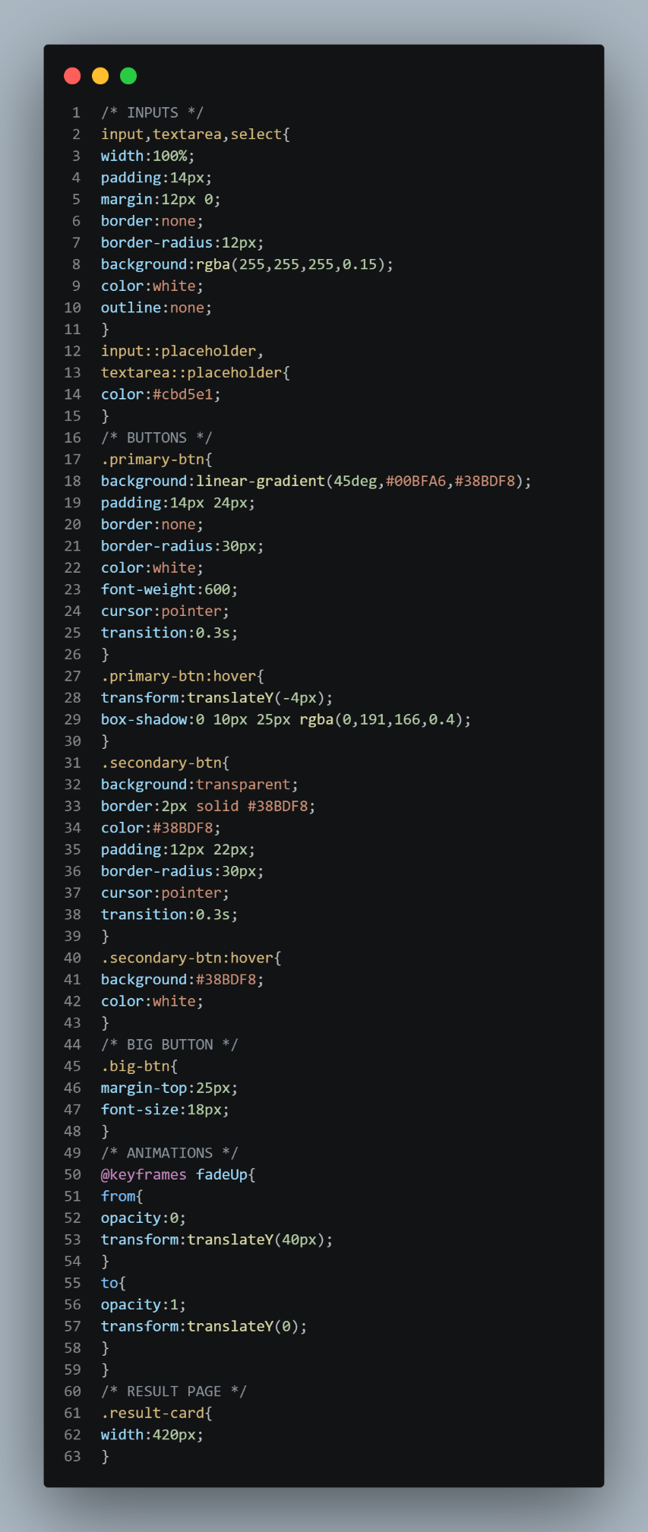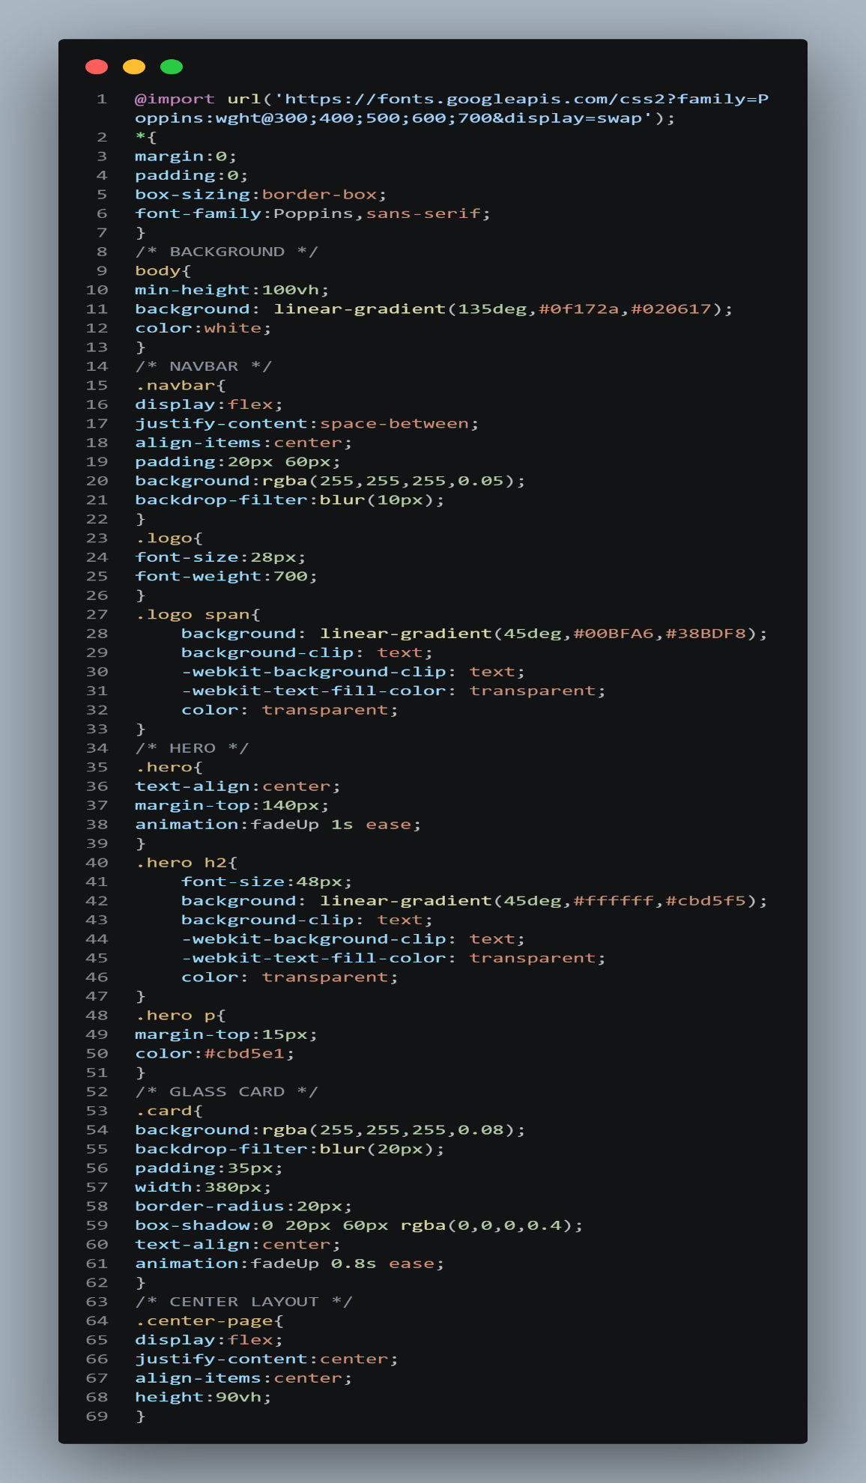
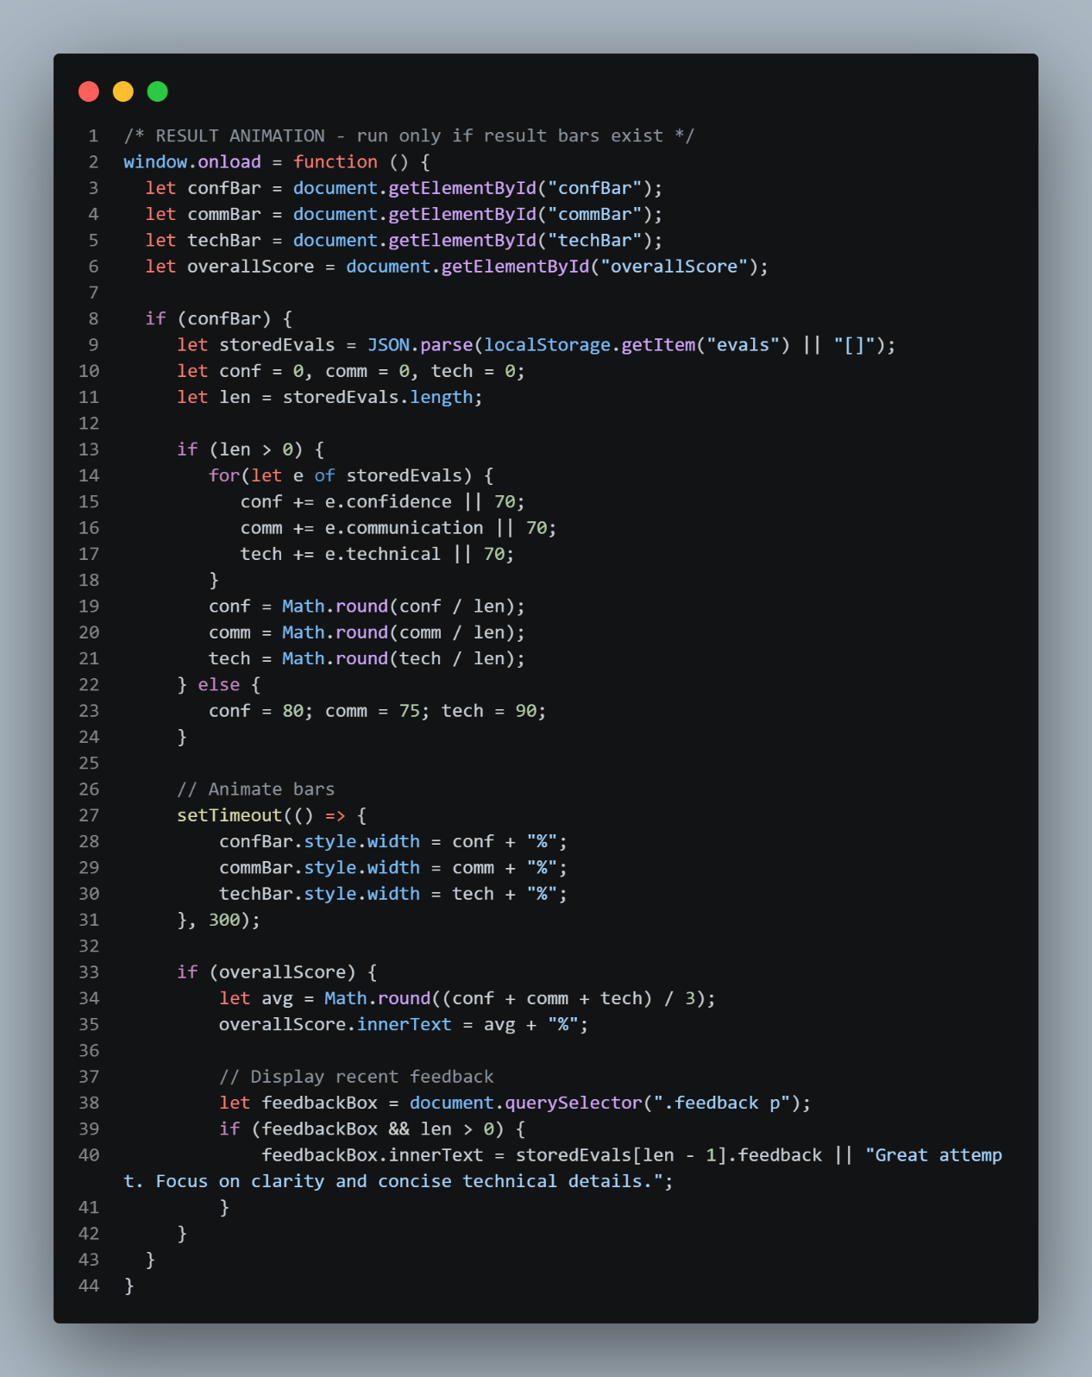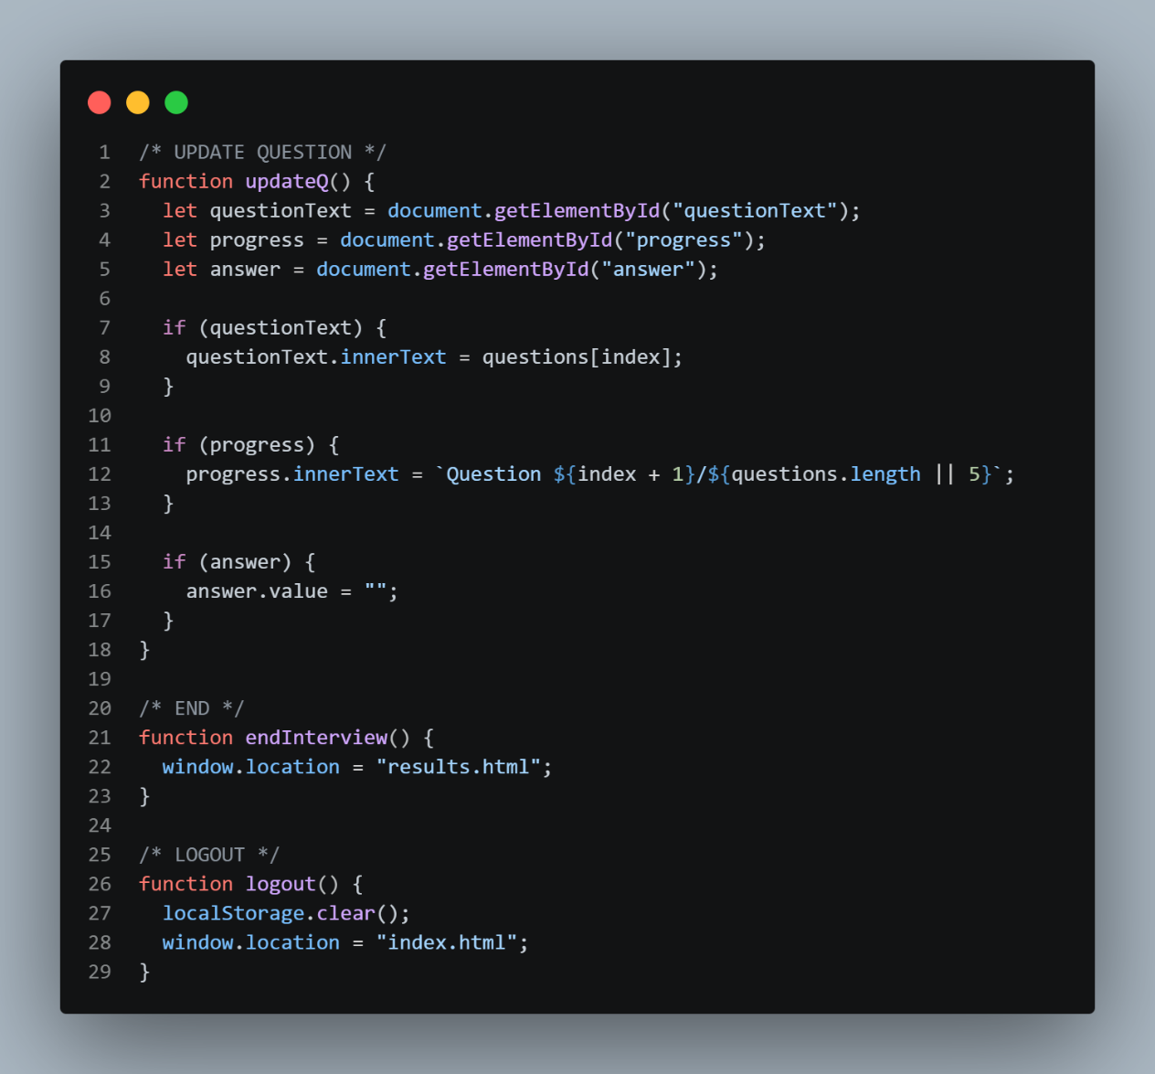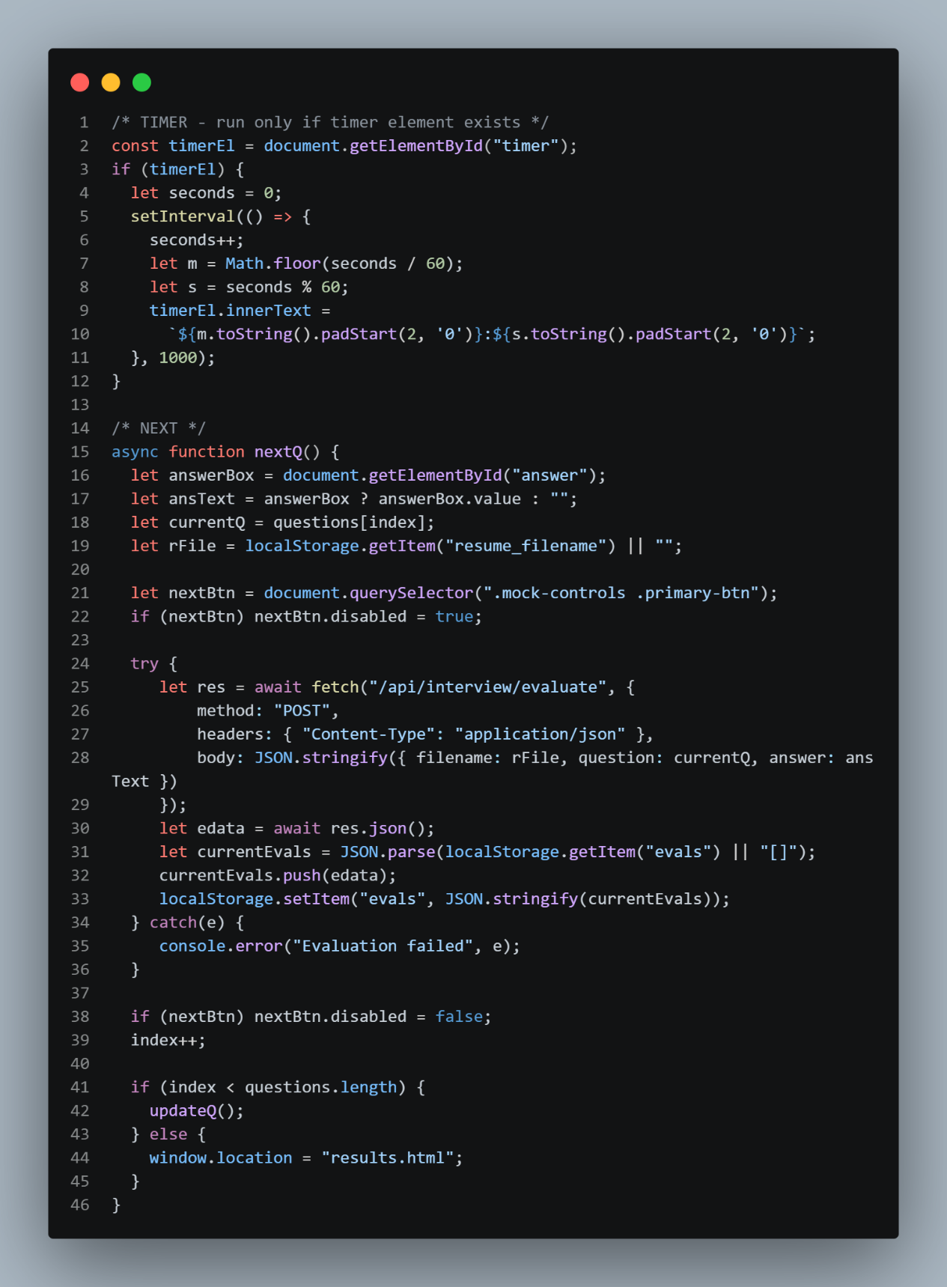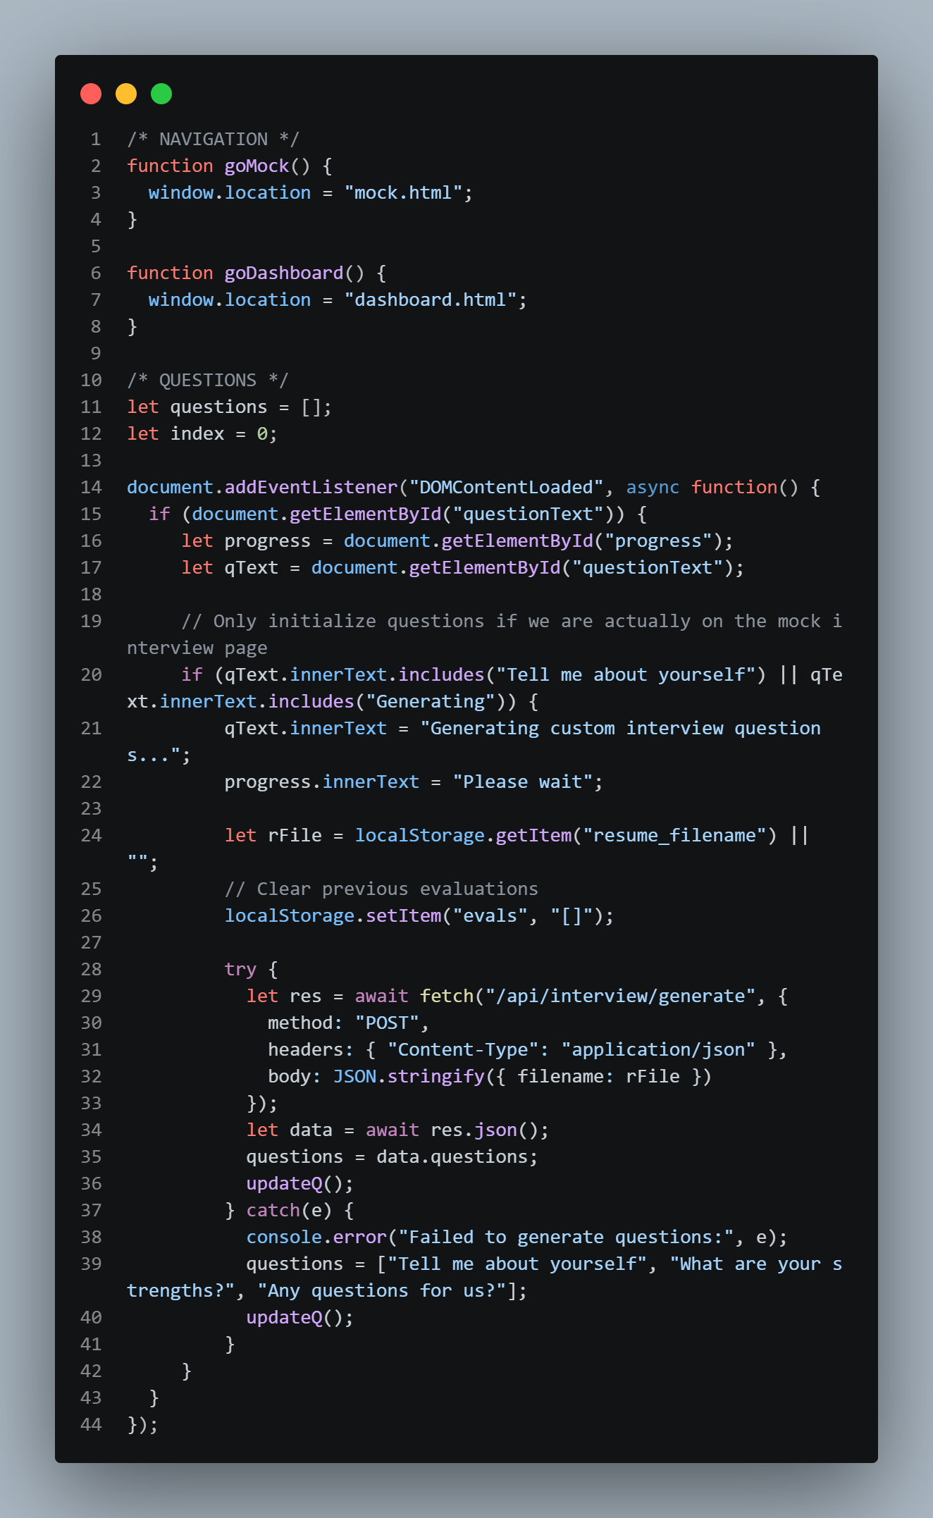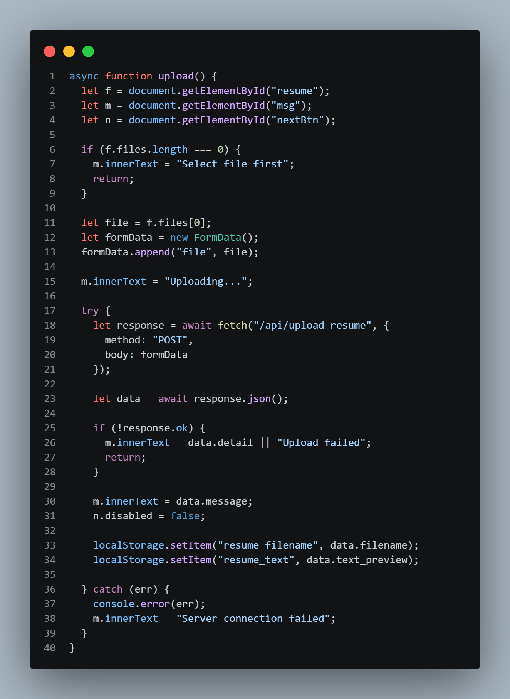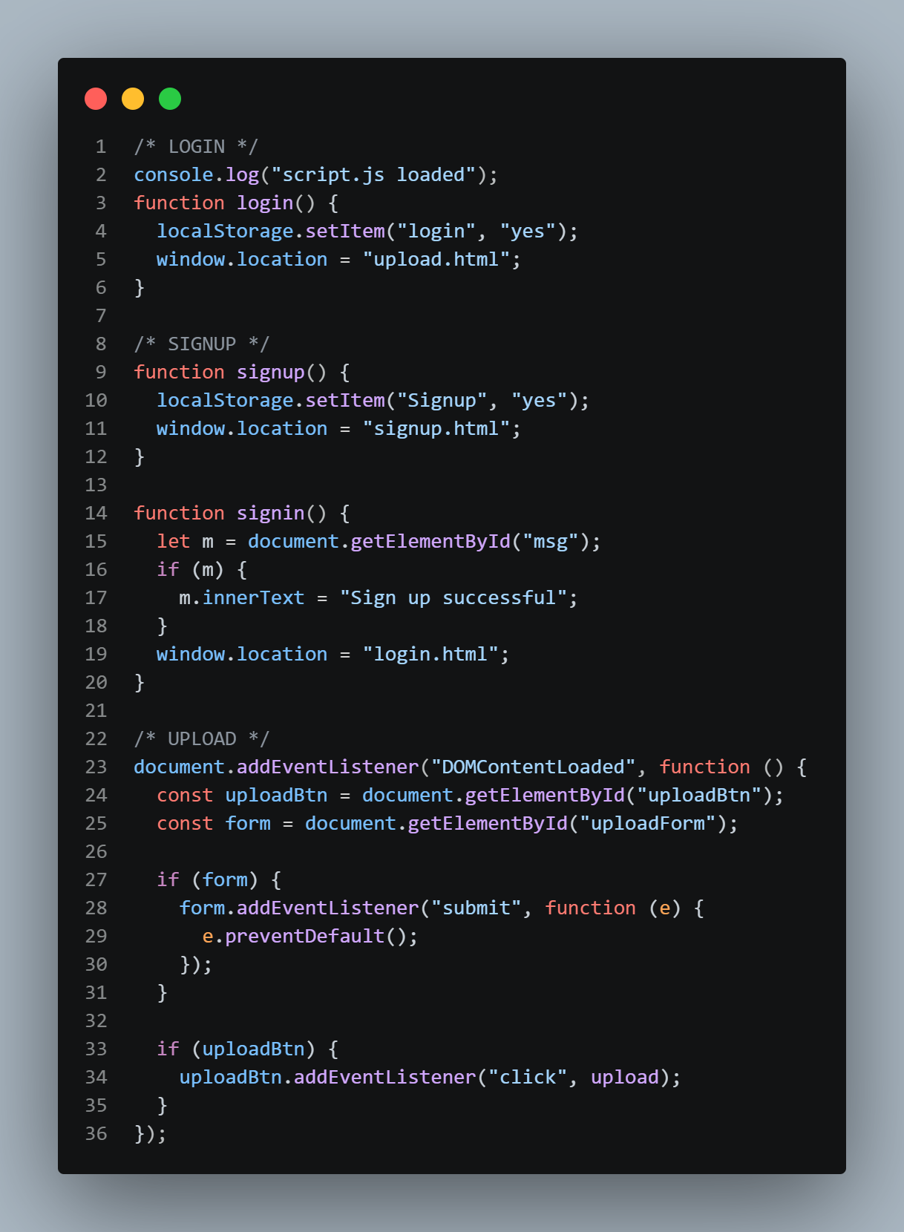
6.2 Backend
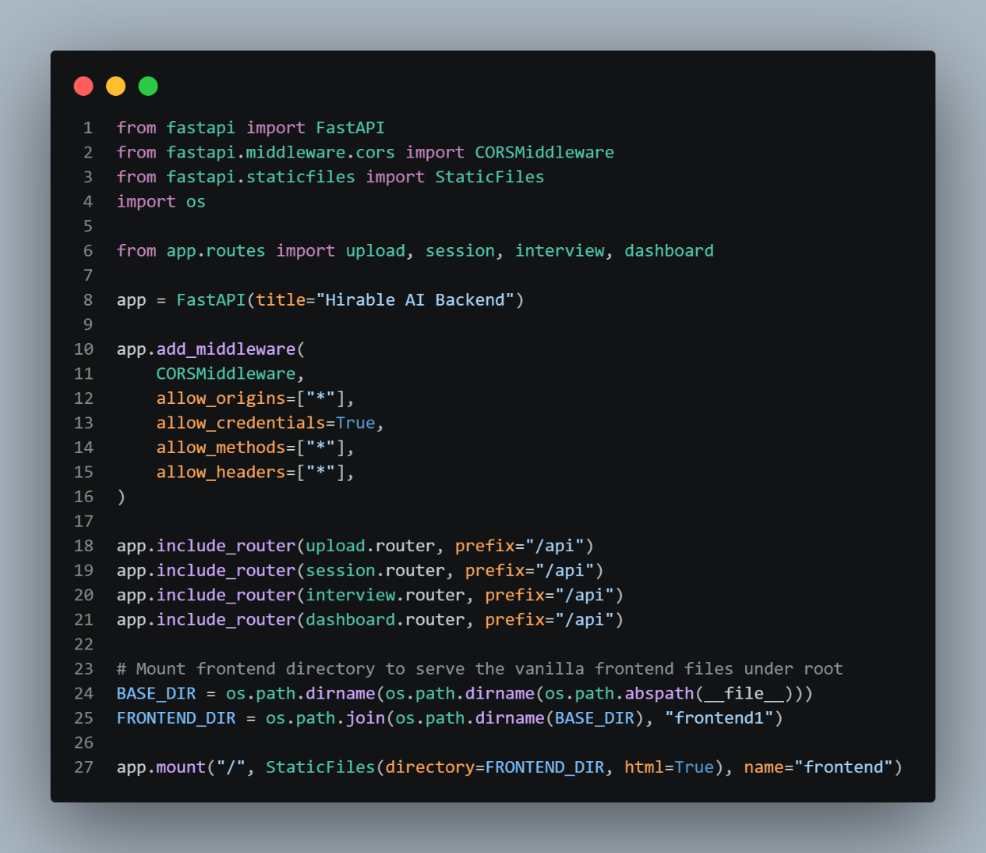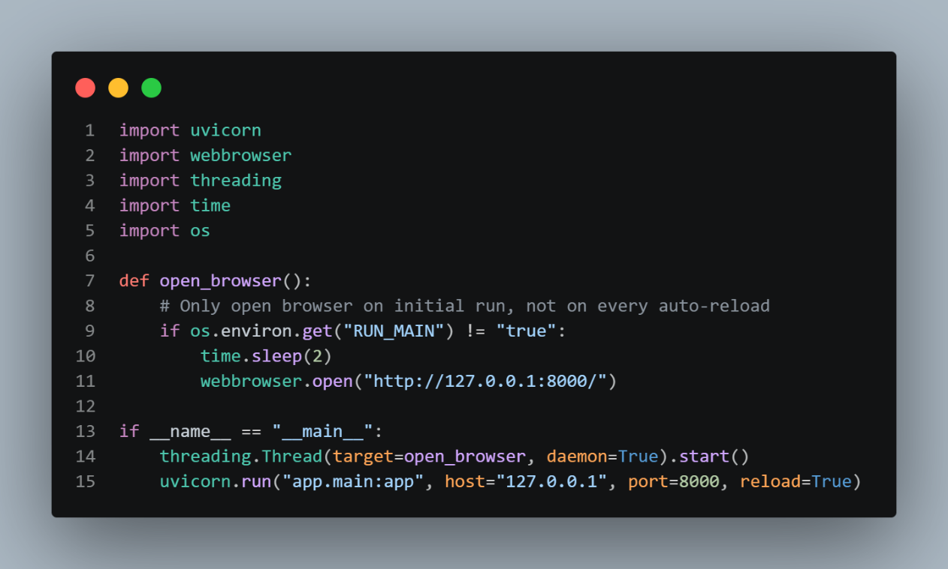
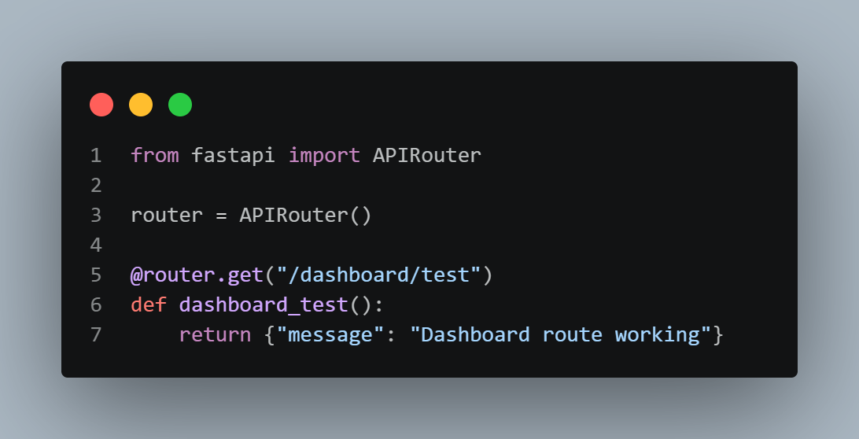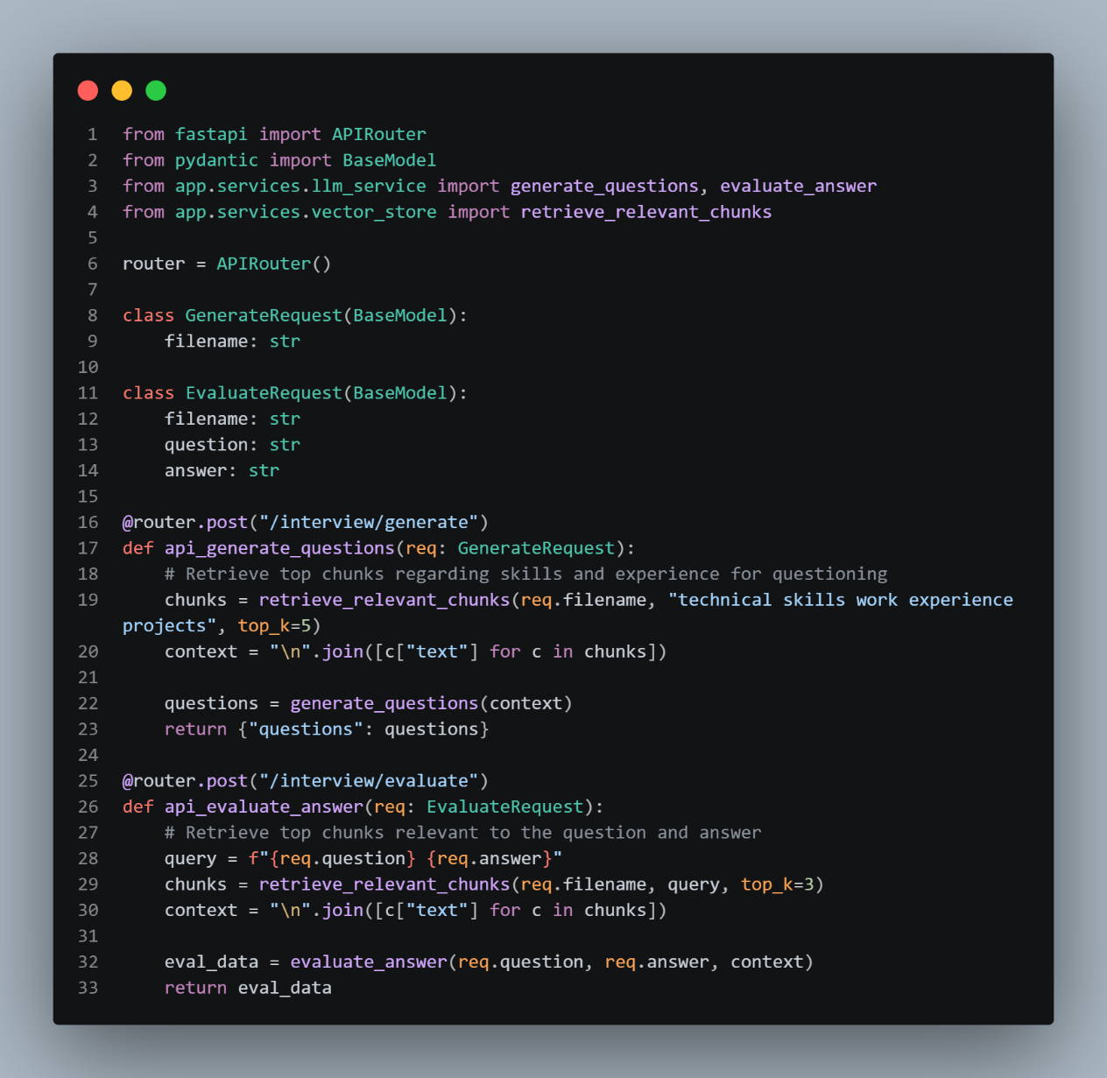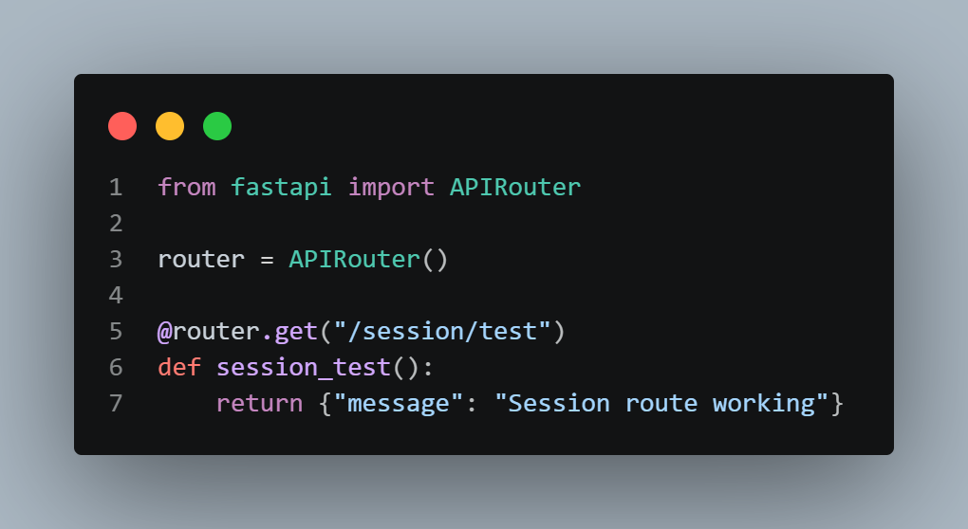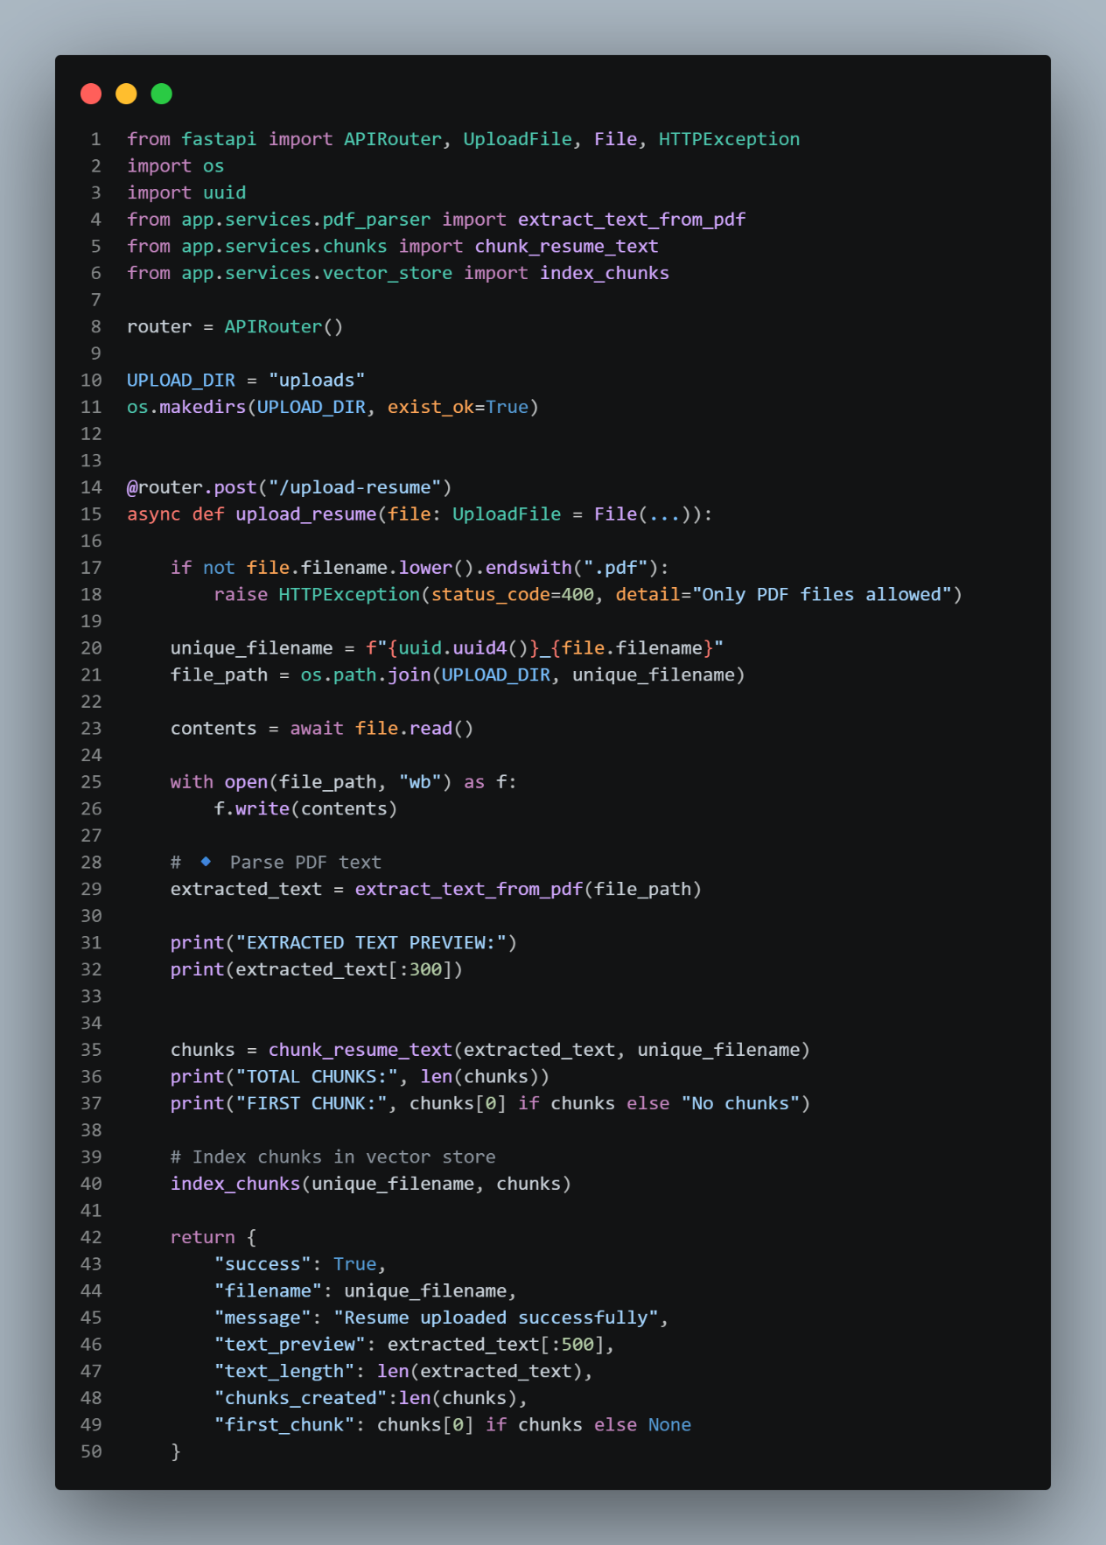

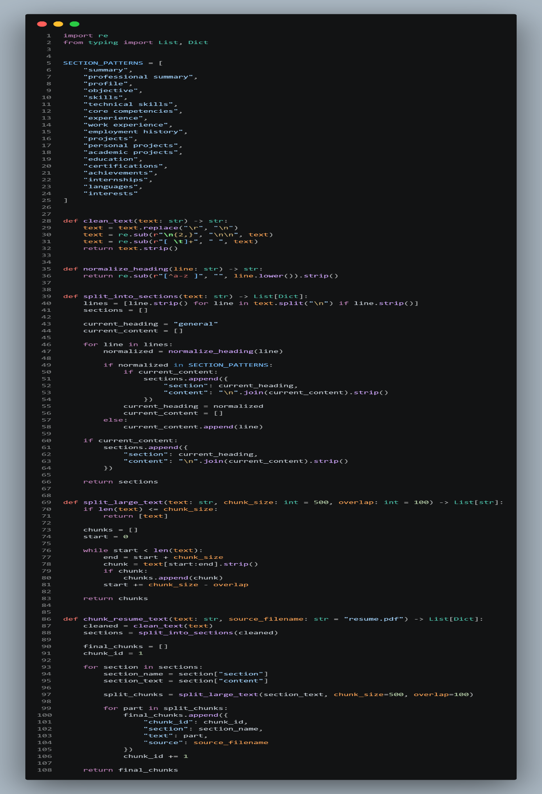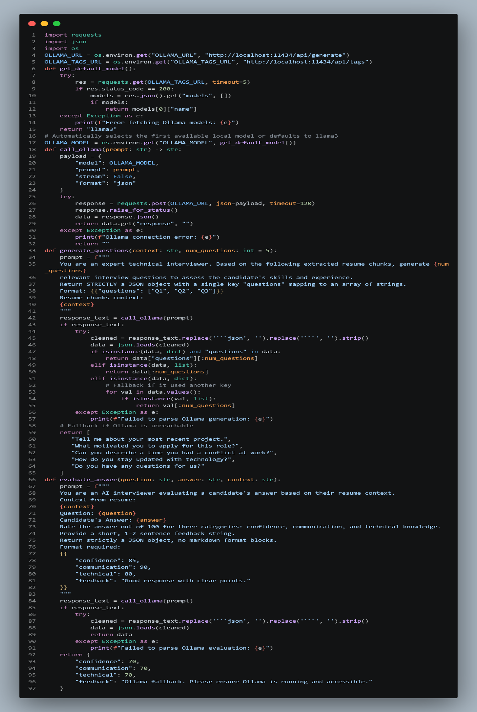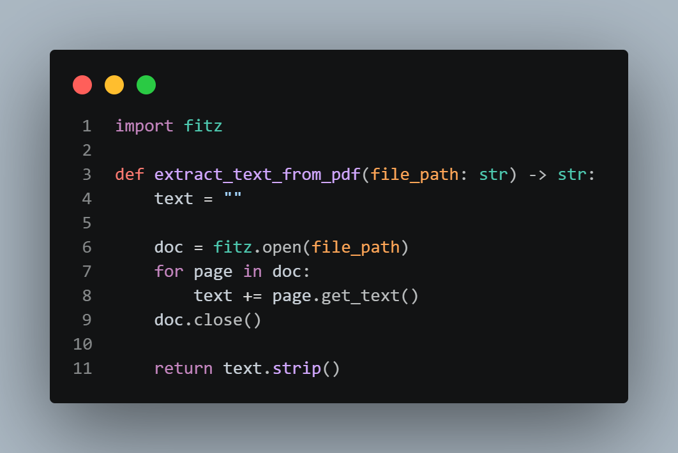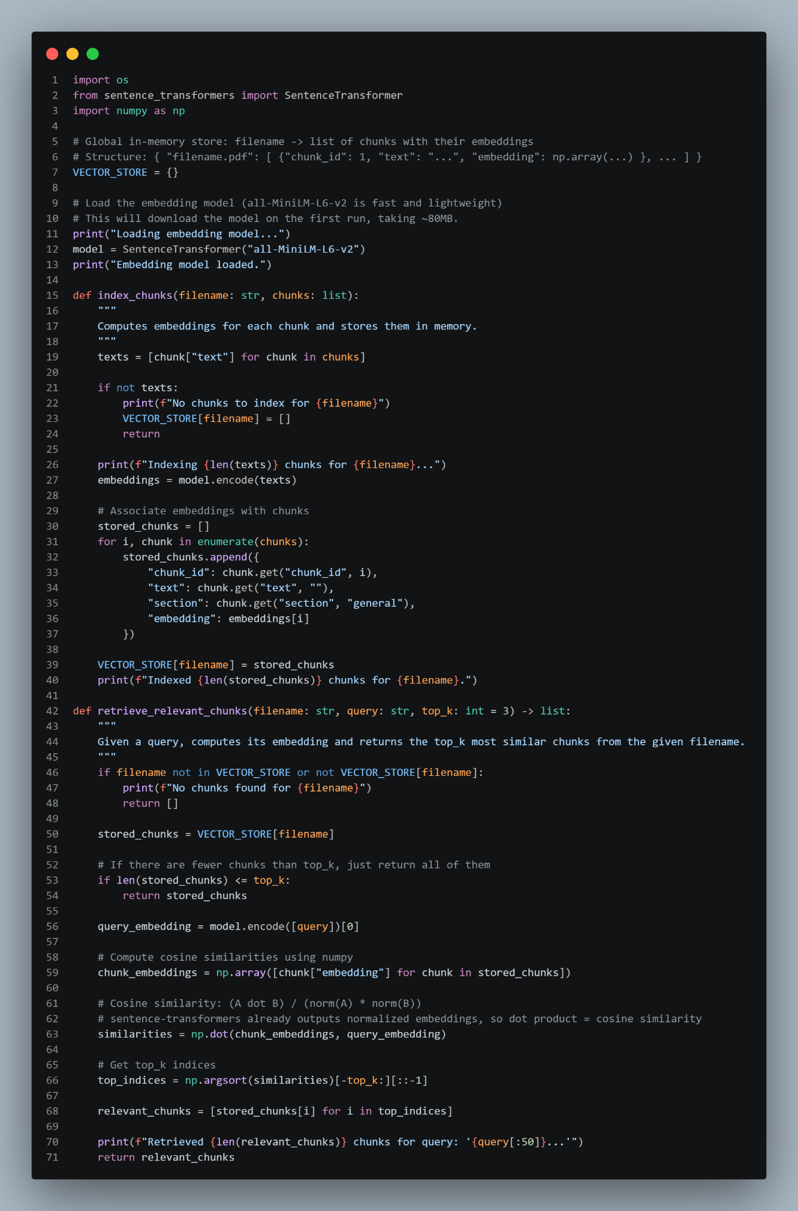
CONCLUSION AND FUTURE SCOPE
Conclusion:
HirableAI is a full-stack web application designed to help job seekers and students prepare for interviews using AI-powered mock interviews. The system successfully implements a resume-based question generation and answer evaluation framework, where users can upload their resume, answer generated questions, and receive feedback in terms of confidence, communication, and technical knowledge.
Key outcomes of the project include:
- Automated Resume Analysis: Extracts and processes resume content efficiently using PyMuPDF and embedding models.
- Intelligent Question Generation: Uses AI to create personalized questions tailored to the user’s experience and skills.
- AI-Powered Answer Evaluation: Scores answers and provides feedback, giving users insights to improve their interview performance.
- User-Friendly Interface: Frontend designed with simple navigation, clear instructions, and result visualization using animated skill bars.
- Local and Lightweight Architecture: FastAPI backend with in-memory storage allows quick prototyping without a complex database setup.
The system demonstrates a retrieval-augmented AI workflow, combining semantic search and language models to produce meaningful interactions. This project showcases the integration of AI with web development to solve a practical problem—interview preparation.
Limitations:
Despite its successful implementation, HirableAI has some limitations:
- No Secure Authentication: Login/signup is simulated; real security is not implemented.
- Volatile Data Storage: Uses in-memory vectors and local Storage; data is lost on server restart.

- Open CORS Policy: Not secure for production use.
- Dependence on Local AI Model: Evaluation quality depends on the availability and quality of the Ollama model.
- Limited Error Handling: Large or malformed PDFs may cause errors, and some routes are placeholders.
- No Persistent History or Analytics: Users cannot track past interview sessions.
Future Scope:
The project has significant potential for enhancement:
- Secure User Management: Implement JWT/OAuth authentication, password hashing, and role-based access.
- Persistent Storage: Use a database for resumes, sessions, and vector embeddings (e.g., FAISS, Chroma, or pgvector).
- Enhanced AI Evaluation: Improve prompts, scoring consistency, and multi-language support.
- Analytics Dashboard: Show trends, improvement graphs, and session history.
- File Validation & Security: Add robust PDF validation, rate limiting, and input sanitization.
- Scalable Architecture: Deploy using Docker, HTTPS, reverse proxy, and cloud hosting.
- Automated Testing & CI/CD: Add unit, integration tests, and continuous deployment pipelines.

REFERENCE/BIBLIOGRAPHY
Below is a list of sources referenced during the development of HirableAI, including documentation, articles, and books on AI, web development, and PDF processing. Sources are listed in alphabetical order.
- Chollet, F. (2018). Deep Learning with Python. Manning Publications.
- FastAPI Documentation. (2026). FastAPI framework for building APIs with Python. Retrieved from https://fastapi.tiangolo.com
- Hugging Face. (2026). Sentence Transformers Documentation. Retrieved from https://www.sbert.net/
- Müller, F. (2023). PyMuPDF (fitz) Documentation. Retrieved from https://pymupdf.readthedocs.io
- Ollama. (2026). Ollama Local LLM API Documentation. Retrieved from https://ollama.com/docs
- Raschka, S., & Mirjalili, V. (2019). Python Machine Learning: Machine Learning and Deep Learning with Python, scikit-learn, and TensorFlow 2. Packet Publishing.
- W3Schools. (2026). HTML, CSS, and JavaScript Tutorials. Retrieved from https://www.w3schools.com
- Wikipedia Contributors. (2026). Client–Server Model. In Wikipedia. Retrieved from https://en.wikipedia.org/wiki/Client%E2%80%93server_model
- Zhang, Y. (2021). Retrieval-Augmented Generation (RAG) for NLP Applications. arXiv preprint. Retrieved from https://arxiv.org/abs/2005.11401

